Risk Assessment Template

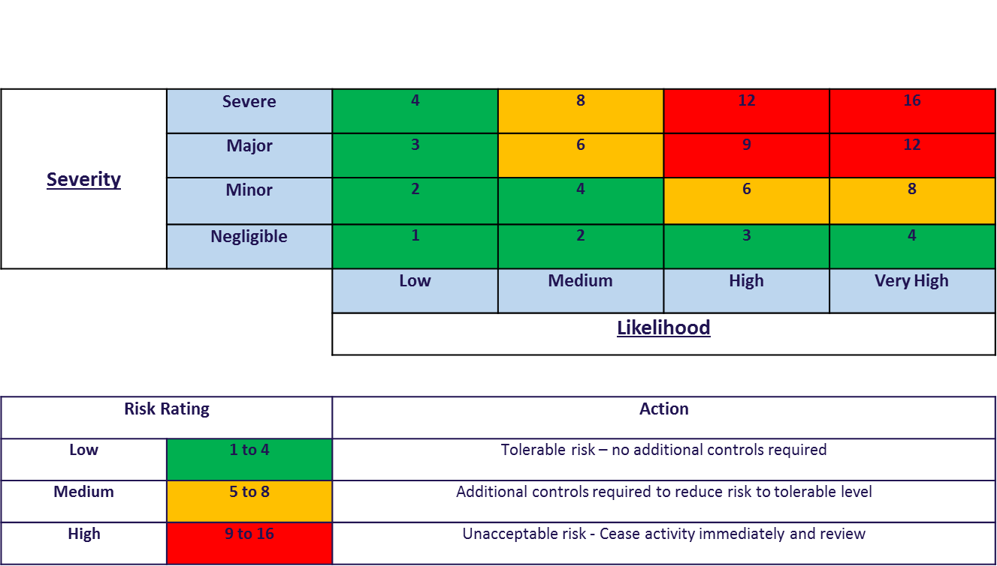
Risk Assessment Matrix

Hazard: Something that has the potential to cause harm
Risk: The likelihood of someone being harmed
To calculate the Risk Rating for the assessment form then use the following equation based on the matrix
Risk Rating = Severity x Likelihood

Risk Assessment Template

Club Name: |  | Assessment No: | Date:
Assessed by:  Signature: | Location: | Activity: | Review date:

What has the potential  To cause harm (hazards) and what harm might result? | Who and how many people might be at risk? | What measures are already in place? | Severity | Likelihood | Risk rating | Further action required, by whom, timescale or reference to other documents plus information

