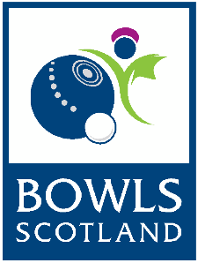
BIBC/BIWBC
International Series 2020
Selection Policy

The purpose of the BIBC/BIWBC Selection Policy is to ensure the best possible squads, teams and players are selected to achieve maximum success when representing Scotland during the BIBC/BIWBC International Series in 2020.
Player Eligibility
In order to be eligible to be selected to represent Scotland in any BIBC/BIWBC Competition/Event players must:
- Be a playing member of a Bowls Scotland affiliated club
- BIWBC Juniors & BIBC Juniors must be within the age restrictions as detailed below:
  - BIWBC: Applicants must be 25 or under on or before 1st April 2020
  - BIBC: Applicants must be under 25 as at 1st April 2020
Selection Criteria
Selection will be based on:
- Pre-selection through nominations by the Bowls Scotland High Performance Head Coach from the current World Championship squad.
- Pre-Selection through nominations from the panel of officials from the medal winners from previous four years events – World Championships, Atlantic Championships & Commonwealth Games 2018
- Application Form: Proven experience and/or success at recognised competitions as detailed in the application form and submitted by the closing date
- Named nominations from City & County Representatives (BIBC only) submitted by the closing date
- Performance at Trials
- Team dynamics and personal attributes
Please note:
- Players must attend Trial Days (even if pre-selected, with the exception of players who are in attendance at the World Championships 2020)
- All successful players must attend the Team Squad Days (even if pre-selected)
- Bowls Scotland will inform all applicants of their selection or non-selection in writing
- Once players have been offered a place on the team they will have a time limit to accept the offer. If no response is received by the cut off time detailed in their letter it will be assumed they have declined the offer and another player may be offered the place
- Public notification of the selected players will be made by Bowls Scotland only after all selected players have been notified
- All successful players must adhere to and sign all relevant Bowls Scotland Players Policies and Codes of Conduct
This policy will be available to all Bowls Scotland members through the Bowls Scotland website. Bowls Scotland shall have no responsibility to give notice of this policy to any individual members or clubs.

