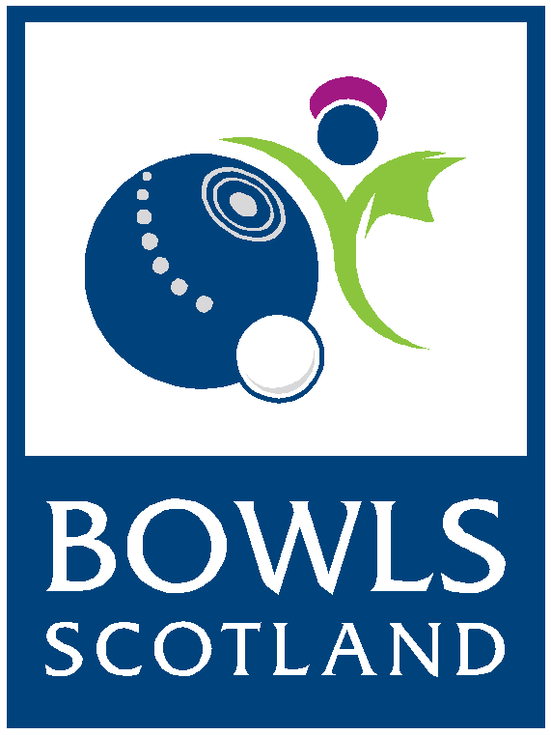**Job Vacancy:**

**Competition & Events Coordinator**

**Responsible to**: Competition & Events Manager

**Job Purpose:** To provide high quality, efficient and customer focused administrative and general support services to customers, volunteers and the Competition & Events team.

**Location:** The successful candidate will be based at Bowls Scotland’s National Centre for Bowling, Ayr

Bowls Scotland in the National Governing Body for lawn bowls in Scotland with 849 clubs and over 55,000 members.

**Our vision:** Bowls – at the heart of your community, active, modern and accessible to all.

**Our mission:**

* To continue to support the development of clubs and competitions
* To encourage women in bowls
* To support excellence in governance being implemented at all levels of bowls in Scotland
* To support players in achieving their full potential
* To promote a more positive image of our sport

This is an exciting time to join Bowls Scotland as we are about to commence a new strategy period (2019-2023) which will look at ways to introduce a new competition structure to increase the opportunities available to female bowlers as well as develop the current competitions.

**Key responsibilities:**

* Provide administrative support within the Competition & Events team to enable delivery of the Calendar of Events
* Undertake core administrative tasks, including preparation of letters, booking of venues, arranging meetings, catering etc
* Book travel and accommodation for National & International squads
* Liaise with players, coaches and team managers
* Monitoring and administering a range of email in-boxes
* Minute taking at meetings
* Entering, filing, retrieving and maintaining data from a range of computerised and manual systems
* Use draw software to produce competition draws and update results
* Update the website with competition information/draws/results etc
* Issue surveys, gather feedback and produce findings from all competitions/events
* Attend competitions/events when required to support delivery as part of the Competition & Events team
* Work with the Marketing & Communications Officers to promote all competitions
* Order clothing, medals and any other equipment/items as and when required
* Provide administrative support to the High Performance & Para Bowls Managers
* Provide additional support to the office administration team during peak times
* Support the Bowls Scotland strategy and uphold the company values
* Undertake any other duties as appropriate to meet the needs of Bowls Scotland

**This job description is not to be regarded as exclusive or exhaustive. It is intended as an outline indication of the areas of work and will be amended in light of the changing needs of the organisation.**

**Person Specification:**

**Essential:**

* National Certificate, or SVQ Level II or equivalent
* Experience of working with Microsoft Packages (Word, Excel, PowerPoint etc.)
* Experience of working in a customer focused environment dealing with a wide range of enquiries
* Experience of working in an office environment demonstrating excellent office administration skills

**Desirable:**

* Experience of working in a sporting environment
* Knowledge of current competition event practices in lawn bowls or another sport

**Skills & abilities:**

* Self-motivated, energetic and a positive approach to work
* Communicates in a well-structured, concise and clear way, both verbally and in writing
* Distinguishes between priority and non-essential tasks and plans accordingly
* Deals tactfully and confidently with people of all levels of the organisation (both internally and externally) building collaborative relationships
* Displays a flexible approach to meet work requirements
* Willingly accepts responsibility for their own area of work and for delivering required results
* Excellent organisation, planning and time management skills with the ability to hit deadlines
* Strong and effective communication and interpersonal skills with a track record of working effectively as part of a team
* Excellent attention to detail
* Ability to work under pressure and deliver results against set targets
* A commitment to ongoing professional development
* Willingness to learn new skills where necessary to effectively undertake the role
* A passion for sport
* A sense of humour

**Other:**

* Applicant must hold a full current driving licence and have access to a car. The postholder may be required to travel independently to meetings.
* The role will require some evening and weekend work as and when required.

**Additional Information**

**Contract:**

Permanent - on successful completion of a six-month probationary period from the date of employment.

**Salary:**

£19,000 per annum

**Contracted hours:**

37.5 hours per week

**Location:**

The successful candidate will be based at Bowls Scotland’s National Centre for Bowling, Ayr

**Holidays:**

The Employer’s holiday year runs from 1st January to 31st December inclusive. Your full-time entitlement to holiday would, in addition to 10 days public holidays, be 25 working days paid holiday in each year.

**Pension Scheme:**

You are entitled to contribute to a personal pension scheme of your choice provided that the pension scheme you choose is approved by the employer and any appropriate funding body. The governments’ auto-enrolment scheme will be available. More details will be made available at appointment stage.

**Expenses:**

You will be entitled to be reimbursed for all reasonable expenses properly incurred in the performance of your duties in accordance with Bowls Scotland’s Financial procedures.

**Application process:**

The closing date for applications **is 12:00 noon on Friday 27th March 2020**. Applications received after this time will not be considered.

Interviews will be held on Wednesday 8th April 2020.

To apply for this role please fully complete:

* The application form
* Equal opportunities monitoring form
* Attach a current CV

Please return your application marked PRIVATE & CONFIDENTIAL to:

Claire Johnston

Competition & Events Manager

Bowls Scotland

National Centre for Bowling

Hunters Avenue

Ayr

KA8 9AL

Or by email to: [clairejohnston@bowlsscotland.com](mailto:clairejohnston@bowlsscotland.com)

Telephone: 01292 294623