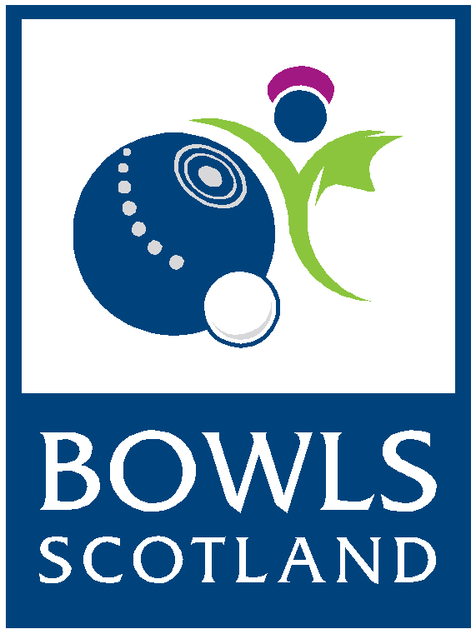**Job Vacancy: Competition & Events Officer**

**Responsible to**: Competition & Events Manager

**Job Purpose:** Lead on the planning anddelivery of all Competitions & Events.

**Location:** The successful candidate will be based at Bowls Scotland’s National Centre for Bowling, Ayr

Bowls Scotland in the National Governing Body for lawn bowls in Scotland with 849 clubs and over 55,000 members.

**Our vision:** Bowls – at the heart of your community, active, modern and accessible to all.

**Our mission:**

* To continue to support the development of clubs and competitions
* To encourage women in bowls
* To support excellence in governance being implemented at all levels of bowls in Scotland
* To support players in achieving their full potential
* To promote a more positive image of our sport

This is an exciting time to join Bowls Scotland as we are about to commence a new strategy period (2019-2023) which will look at ways to introduce a new competition structure to increase the opportunities available to female bowlers as well as develop the current competitions.

**Key responsibilities:**

* Implement a project document for each competition/event and ensure targets/tasks are completed on time
* Plan and administer the Bowls Scotland Calendar of Events
* In conjunction with the Competition & Events manager; plan, monitor and administer event budgets
* Lead the Competition & Events Group (volunteers) on all levels of planning and delivery, including chair of the Competitions & Events meetings
* To manage supplier relationships ensuring contractors are appointed in good time, on budget and in accordance with competition/event requirements
* To project manage all on-site inspections/planning meetings for competitions
* Promote trade stand opportunities at large scale competitions
* Identify marketing opportunities at competitions/events and work closely with the Marketing & Communication Officers
* Work closely with Bowls Scotland official partners to meet competition contractual agreements
* Liaise with South Ayrshire Council and other authorities in support of competitions
* Review all competitions/events and gather feedback where appropriate
* Attend all competitions & events where required
* Work with the Marketing & Communications Officers to promote all competitions
* Submit relevant content for club mailings, newsletters, website and other publications as necessary
* Support the Bowls Scotland strategy and uphold the company values
* Undertake any other duties as appropriate to meet the needs of Bowls Scotland

**This job description is not to be regarded as exclusive or exhaustive. It is intended as an outline indication of the areas of work and will be amended in light of the changing needs of the organisation.**

**Person Specification:**

**Essential:**

* A minimum of three years professional experience of leading a team preferably in an event management environment

**Desirable:**

* Proven experience of planning, delivering and evaluating projects
* Experience of working in the sports industry
* Experience of volunteer management
* Experience of delivering to an agreed budget and timescales
* Knowledge of current competition event practices in lawn bowls or another sport
* Ability to lead and motivate a team in a high-pressure environment
* Ability to write reports and present them as required
* Ability to maintain positive relationships with a variety of stakeholders
* Experience of procurement processes and procedures
* Highly competent in MS Office

**Skills & abilities:**

* Self-motivated, energetic and a positive approach to work
* Excellent organisation, planning and time management skills with the ability to hit deadlines
* Strong and effective communication and interpersonal skills with a track record of working effectively as part of a team
* Ability to work under pressure and deliver results against set targets
* Excellent problem solving and decision-making skills
* Multi-tasked with proven ability to be proactive, work with minimal direction and supervision
* Ability to lead others and to influence others to deliver change
* The ability to show initiative, solve problems and a focus on achieving results
* A commitment to ongoing professional development
* Willingness to learn new skills where necessary to effectively undertake the role
* Excellent attention to detail
* A passion for sport
* A sense of humour

**Other:**

* Applicant must hold a full current driving licence and have access to a car. The postholder will be required to travel independently to meetings on a regular basis.
* The role will require some evening and weekend work.

**Additional Information**

**Contract:**

Permanent - on successful completion of a six-month probationary period from the date of employment.

**Salary:**

£21,000 per annum

**Contracted hours:**

37.5 hours per week

**Location:**

The successful candidate will be based at Bowls Scotland’s National Centre for Bowling, Ayr

**Holidays:**

The Employer’s holiday year runs from 1st January to 31st December inclusive. Your full-time entitlement to holiday would, in addition to 10 days public holidays, be 25 working days paid holiday in each year.

**Pension Scheme:**

You are entitled to contribute to a personal pension scheme of your choice provided that the pension scheme you choose is approved by the employer and any appropriate funding body. The governments’ auto-enrolment scheme will be available. More details will be made available at appointment stage.

**Expenses:**

You will be entitled to be reimbursed for all reasonable expenses properly incurred in the performance of your duties in accordance with Bowls Scotland’s Financial procedures.

**Application process:**

The closing date for applications **is 12:00 noon on Friday 24th January 2020**. Applications received after this time will not be considered.

Interviews will be held on Thursday 6th February 2020.

To apply for this role please fully complete:

* The application form
* Equal opportunities monitoring form
* Attach a current CV

Please return your application marked PRIVATE & CONFIDENTIAL to:

Jett Abernethy

Bowls Scotland

National Centre for Bowling

Hunters Avenue

Ayr

KA8 9AL

Or by email to: [jettabernethy@bowlsscotland.com](mailto:jettabernethy@bowlsscotland.com)

Telephone: 01292 294623