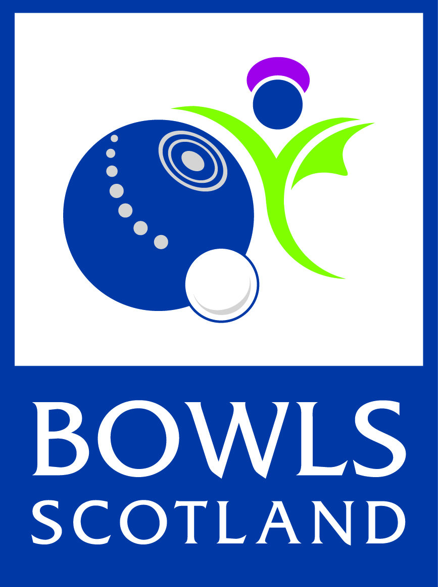
Bowls Scotland
Child Protection Policy

Bowls Scotland is fully committed to safeguarding the welfare of all children in its care. It recognises the responsibility to promote safe practice and to protect children from harm, abuse and exploitation. For the purposes of this policy and associated procedures a child is recognised as someone under the age of 18 years.

Staff and volunteers will work together to embrace difference and diversity and respect the rights of children and young people.

This document outlines Bowls Scotland commitment to protecting children.

This policy is based on the following principles:
- The welfare of children is the primary concern.
- All children, whatever their age, culture, disability, gender, language, racial origin, socio-economic status, religious belief and/or sexual identity have the right to protection from all forms of harm and abuse.
- Child protection is everyone’s responsibility.
- Children have the right to express views on all matters which affect them, should they wish to do so.
- Organisations shall work in partnership together with children and parents/carers to promote the welfare, health and development of children.

Bowls Scotland will:
- Promote the health and welfare of children by providing opportunities for them to take part in bowls safely.
- Respect and promote the rights, wishes and feelings of children.
- Promote and implement appropriate procedures to safeguard the well-being of children and protect them from abuse.
- Recruit, train, support and supervise its staff, members and volunteers to adopt best practice to safeguard and protect children from abuse and to reduce risk to themselves.
- Require staff, members and volunteers to adopt and abide by this Child Protection Policy and associated procedures.
- Respond to any allegations of misconduct or abuse of children in line with this Policy and associated procedures as well as implementing, where appropriate, the relevant disciplinary and appeals procedures.
- Observe guidelines issued by local Child Protection Committees for the protection of children.
- Regularly monitor and evaluate the implementation of this Policy and the associated procedures.

Review

This Policy and associated procedures will be regularly reviewed:
- In accordance with changes in legislation and guidance on the protection of children or following any changes within Bowls Scotland.
- Following any issues or concerns raised about the protection of children within Bowls Scotland.
- In all other circumstances, at least every three years.
Bowls Scotland
Code of Conduct for working with children

Bowls Scotland supports and requires all members to observe the following standards of practice, including verbal and non-verbal actions when involved in activities with children.

All concerns about breach of this Code of Conduct will be taken seriously and responded to in line with Bowls Scotland Complaints Policy, Disciplinary Procedure and Procedure for Responding to Concerns about Child Abuse.

GOOD PRACTICE

- Make sport fun, enjoyable and promote fair play.
- Treat all children equally, with respect, dignity and fairness.
- Involve parents/carers wherever possible.
- Build balanced relationships based on mutual trust.
- Include children in the decision-making process wherever possible.
- Always work in an open environment, wherever possible. Avoid private or unobserved situations.
- Put the welfare of each child first before winning or achieving performance goals.
- Be an excellent role model including not smoking or drinking alcohol in the company of children.
- Give enthusiastic and constructive feedback rather than negative criticism.
- Recognise the developmental needs and capacity of children.
- Avoid excessive training and competition, pushing children against their will and putting undue pressure on them.

PRACTICE TO BE AVOIDED

In the context of your role within Bowls Scotland, the following should be avoided:

- Having ‘favourites’ – this could lead to resentment and jealousy by other children and could be misinterpreted by others.
- Spending excessive amounts of time alone with children away from others.
- Entering children’s bedrooms on trips away from home, unless in an emergency situation or in the interest of health and safety. If it is necessary to enter rooms, knock and say that you are coming in. The door should remain open, if appropriate.
- Where possible, doing things of a personal nature for children that they can do for themselves.

UNACCEPTABLE PRACTICE

In the context of your role within Bowls Scotland, the following practices are unacceptable:

- Engaging in sexually provocative games, including horseplay.
- Engaging in rough or physical contact unless it is permitted within the rules of the game or competition.
- Forming intimate emotional, physical or sexual relationships with children.
- Allowing or engaging in touching a child in a sexually suggestive manner.
- Allowing children to swear or use sexualised language unchallenged.
- Making sexually suggestive comments to a child, even in fun.
- Reducing a child to tears as a form of control.
- Allowing allegations made by a child to go unchallenged, unrecorded or not acted upon.
- Inviting or allowing children to stay with you at your home.
- A Coach and/or other leader sharing a room alone with a child.

Sign-up:

I have read and agree to abide by this Code of Conduct

I have also read and agree to abide by Bowls Scotland Child Protection Policy, Procedures and Guidelines.

Name of staff member/volunteer:

Signature:

Date signed:

Witnessed by:
(Child Protection Officer, if possible)

Signature:

Date signed:

