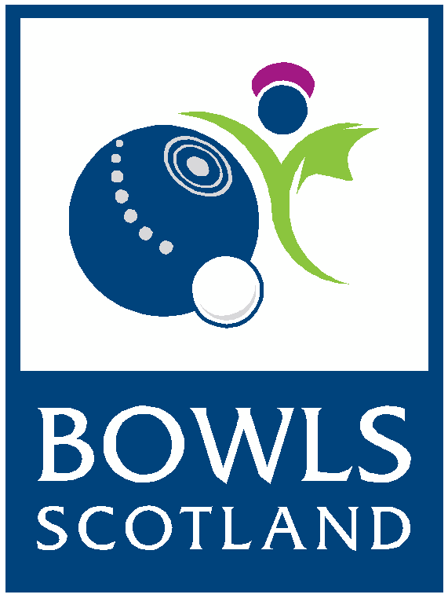
BIWBC Junior
International Series 2019
Application Form

Please read the following details before completing the application form:

- Applications are welcomed from anyone wishing to be considered for trial
- Applicants must be 25 or under on or before 1st April 2019 to be able to play in the BIWBC Junior Team
- Closing date for submitting an application is Friday 12th April, no late applications will be considered
- Your application will be acknowledged by email upon receipt
- You will be advised whether your application has been successful by Friday 10th May
- Successful Applicants must attend the BIWBC Junior Trial day on Saturday 22nd June at the National Centre for Bowling, Northfield, Hunters Avenue, Ayr, KA8 9AL
- Those selected to represent Scotland at the International Series must attend the Squad day which will take place on Sunday 14th July at the National Centre for Bowling, Northfield, Hunters Avenue, Ayr, KA8 9AL
- Please note; travel expenses to Trial & Squad days will not be covered by Bowls Scotland
- The BIWBC Junior International Series will take place at the National Centre for Bowling, Northfield, Hunters Avenue, Ayr, KA8 9AL on the 20th & 21st July. (Players to arrive on 19th July and depart for home on 21st July) Accommodation will be provided.

- Application Forms must be returned either by email or post to the following:
Bowls Scotland
National Centre for Bowling
Northfield
Hunters Avenue
Ayr
KA8 9AL

Email: BIWBC@bowlsscotland.com
Telephone Enquiries: 01292 294623

Further information on the selection process can be found on the Bowls Scotland website: www.bowlsscotland.com

APPLICATION FORM
BIWBC Junior International Series 2019
Please complete the application form in BLOCK capitals

PERSONAL INFORMATION

Name:

Address:

Post Code:

Telephone Number:

Date of Birth:

Email address:

Name of club:

T-Shirt Size: XS S M L XL XXL XXXL Other…………..
Jacket Size: XS S M L XL XXL XXXL Other…………..

Please note:
The selection process will be re-aligned and Trials will take place on Saturday 31st August 2019 for selection of the squad for the International Series 2020.
Please indicate whether you would like to be considered for Trials in August?
Y / N *please delete as appropriate

PERSONAL ACHIEVEMENTS
Please complete the details of your achievements, showing all honours, at the following levels over the past 3 years:

British Isles Level
2018

2017

2016

National Level (second stage)
2018

2017

2016

County Level (Including Torrance Purvis/Inter Association County Games)
2018

2017

2016

Club Level or SYBA
2018

2017

2016

Internationals (PLEASE TICK THE BOXES FOR ANY YEARS YOU HAVE PLAYED AT INTERNATIONAL LEVEL)
2018 | 2017 | 2016 | 2015 | 2014 | 2013 | 2012 | 2011 | 2010 | 2009

How often do you play competitive bowls above club level? (i.e. Representing your club at County/Inter Association or Scottish ties)

Please list any other achievements in support of your application (continue on separate sheet if necessary):

Data Protection
The information provided on this application form will be stored and accessed only by Bowls Scotland. This information will be used for the purpose of selecting players for the BIWBC Internationals in 2019.
I HAVE READ AND UNDERSTOOD THE ABOVE INFORMATION AND GIVE CONSENT FOR MY PERSONAL INFORMATION TO BE USED BY BOWLS SCOTLAND. ALL INFORMATION PROVIDED IN THIS FORM IS TRUE TO THE BEST OF MY KNOWLEDGE.
Signature:
Date:

