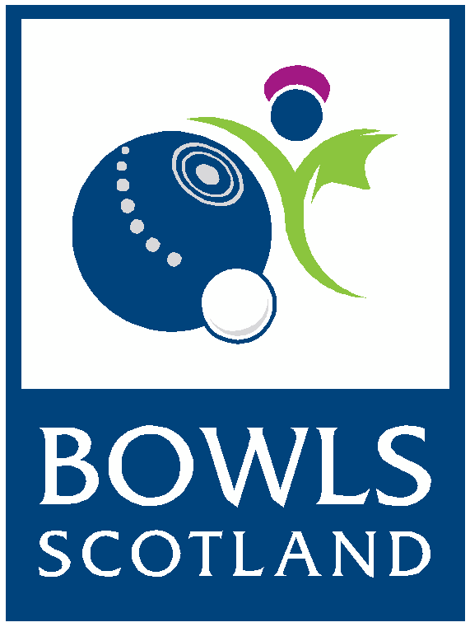
BIBC Junior
International Series 2019
Application Form

Please read the following details before completing the application form:

- Applications are welcomed from anyone wishing to be considered for trial
- Applicants must be under 25 as at 1st April 2019 to be able to play in the BIBC Junior Team
- Closing date for submitting an application is Friday 12th April, no late applications will be considered
- Your application will be acknowledged by email upon receipt
- You will be advised whether your application has been successful by Friday 10th May
- Successful Applicants must attend the BIBC Junior Trial Day on Sunday 2nd June – venue to be confirmed
- Those selected to represent Scotland at the International Series must attend the Squad Day which will take place on Sunday 8th September – venue to be confirmed
- Please note; travel expenses to Trial & Squad days will not be covered by Bowls Scotland
- The BIBC International Series will take place at Essex County Bowling Club, Southend-On-Sea on the 14th & 15th September 2019 (Depart Scotland on 13th September and return on 15th September) Travel and accommodation will be provided. Please note that as flights will be block booked in advance; travel with the team is compulsory on both outward and return journeys.
- Application Forms must be returned either by email or post to the following:
Bowls Scotland
National Centre for Bowling
Northfield
Hunters Avenue
Ayr
KA8 9AL

Email: BIBC@bowlsscotland.com
Telephone Enquiries: 01292 294623

Further information on the selection process can be found on the Bowls Scotland website: www.bowlsscotland.com

APPLICATION FORM
BIBC Junior International Series 2019
Please complete the application form in BLOCK capitals

PERSONAL INFORMATION

Name:

Address:

Post Code:

Telephone Number:

Email address:

Date of birth:

Name of club:

Shirt Size: XS S M L XL XXL XXXL Other…………..

Jacket Size: XS S M L XL XXL XXXL Other…………..

PERSONAL ACHIEVEMENTS
Please complete the details of your achievements, showing all honours, at the following levels over the past 3 years:

British Isles Level
2018

2017

2016

National Level (second stage)
2018

2017

2016

County Level (Including AHT)
2018

2017

2016

Club Level/SYBA

2018

2017

2016

Internationals (PLEASE TICK THE BOXES FOR ANY YEARS YOU HAVE PLAYED AT INTERNATIONAL LEVEL)
2018 | 2017 | 2016 | 2015 | 2014 | 2013 | 2012 | 2011 | 2010 | 2009

How often do you play competitive bowls above club level? (i.e. Representing your club at County/Inter Association or Scottish ties)

Please list any other achievements in support of your application (continue on separate sheet if necessary):

Data Protection
The information provided on this application form will be stored and accessed only by Bowls Scotland. This information will be used for the purpose of selecting players for the BIWBC Internationals in 2019.
I HAVE READ AND UNDERSTOOD THE ABOVE INFORMATION AND GIVE CONSENT FOR MY PERSONAL INFORMATION TO BE USED BY BOWLS SCOTLAND. ALL INFORMATION PROVIDED IN THIS FORM IS TRUE TO THE BEST OF MY KNOWLEDGE.
Signature:

Date:

