Green Grass Bowling CLUB

Love Bowls? Looking for a club? Want to learn how to play? Join our Club!

Green Grass Bowling club is located in the heart of our community within easy walking distance of the town centre. Our quiet club is a perfect place to play bowls and spend time with your friends. We pride ourselves on the family-friendly environment and welcoming atmosphere for bowlers of all abilities.
Don’t just take our word for it, come and pay us a visit to find out more.
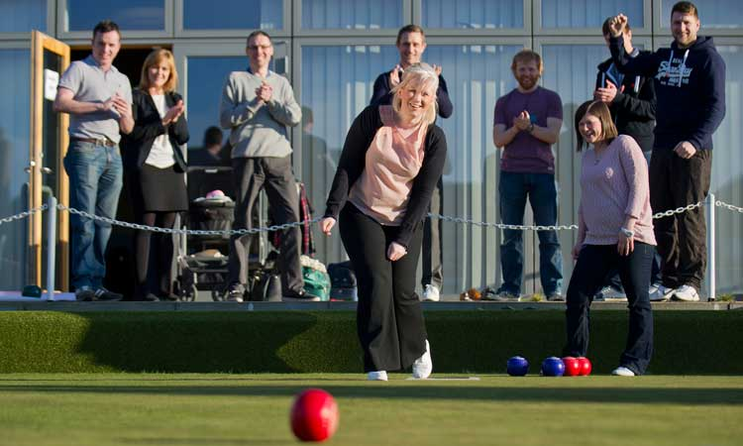
Why join the club?
Play Bowls!
- Great condition green open April to September
- Green is open every day for members to play
- Indoor short mat bowls for the winter months
- Learn and improve with our bowls coaches
Great Clubhouse
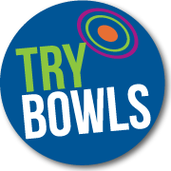
- Bar & lounge to relax in before and after your game
- Best value bar in town!
- Great range of drinks from barista coffee to local ales
- Members and visitors changing rooms
- Lockers available to keep your equipment in
- FREE function room hire for members – birthdays, weddings, etc.
- FREE parking for members

Competition Bowls
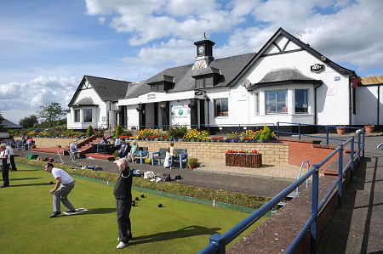
- Weekend and midweek competitions for men, women, seniors, juniors and mixed categories
- Weeknight hat games – every Tuesday!
- Club Championships & Trophies to be won
- Compete for the club team, at county and national championships

Looking After Our Members
- Regular communication through our members e-newsletter
- Updates on the Club Facebook page
Green Grass Bowling CLUB
Membership Fees 2018

*SPECIAL OFFER 1 - Join before 1st May and save £ 10
**SPECIAL OFFER 2 – Refer a Friend and save £ 50 !

* Pay £100 subscription instead of £110.
** Recommend a friend to join and you’ll receive £50 discount on your next year

Membership Fees 2018
Full Member | £110
Social | £40
Juniors: Under 12 years | Only £5!
Juniors: 12-17 years of age | £20
Intermediate: 18-25 years of age | £75

Payment Options
We offer a variety of payment options for membership including direct debit, cheque and BACS. Once you’re a member, you can also save for your membership through your bar loyalty card.

Joining Process
Once you have completed the form attached simply return to the club in person, by post or send via e-mail to club@greengrassbc.com

Once your membership is confirmed you will receive an induction pack that details your membership benefits and all the information you will require as a first year member of Green Grass Bowling Club, including notice of our New Members Event.

We look forward to hearing from you!

Green Grass Bowling CLUB

Name:
Gender
Date of Birth:
Occupation:
Address:
E-Mail:
Contact Tel:
Current/Previous Club:
Category of Membership:
How Did You Find Out About Us?
Referring Member (if applicable):

Please complete and return the form to:
John Smith, Club Secretary
Green Grass Bowling Club, Town, AB1 1AB

Email: club@greengrassbc.com
Facebook: facebook.com/greengrassbc
Twitter: @greengrassbc

