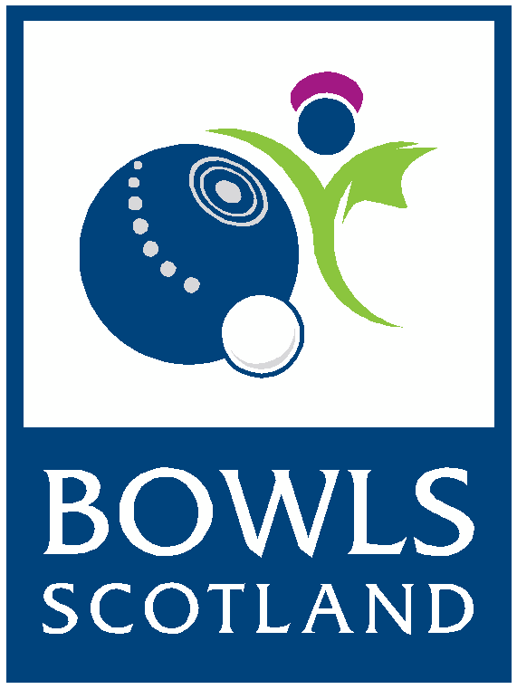

National Championships 2018
Volunteer Application Form

Thank you for your interest in volunteering at the National Championships; the biggest club event in lawn bowls attracting over 10,000 spectators during the 6 days of competition. We consider our volunteers to be essential to the smooth running of the event – we couldn’t do it without you!

The Event:
The National Championships will run from Monday 23rd – Saturday 28th July 2018 at the National Centre for Bowling, Ayr.

Typical volunteer roles and tasks:
- Helping with event set up and de-rig (this could involve some heavy lifting)
- Displaying signs
- Assisting officials / scorecard runner
- Assistant to event press officer
- Providing additional help to event staff
- Assisting with organisation of participants, ensuring players are in the right place at the right time
- Helping with stewarding
- Guiding spectators
- Help in keeping sites safe and tidy and free from litter
- Scoreboard operator
- Scoreboard markers
- Hospitality host

Please return your completed form by email to Competitions & Events Officer by email: candeofficer@bowlsscotland.com or by posting to the address below by Friday 15th June 2018.
Thank you
National Championships Team
Bowls Scotland
National Centre For Bowling
Northfield, Hunters Avenue,
Ayr KA8 9AL
Tel: 01292 294623
Email: candeofficer@bowlsscotland.com

National Championships 2018
Volunteer Application Form

Name: …………………………………………………………………………………………………
Address: ……………………………………………………………………………………………
…………………………………………………………………………………………………………..
Post Code: ………………………………………………………………………………………….
Telephone Number: ……………………………………………………………………………..
Email Address: ……………………………………………………………………………………

All volunteers will receive an information pack by email one week before the National Championships to brief you on the details of the event, you will also receive a list of your duties and rota. If you have any questions these can be answered when you arrive for your first shift.
When you arrive on site you will also receive an accreditation pass. If you are new to the National Centre we will be happy to give you a tour!

Volunteer Availability:
Please indicate on the table below your availability to volunteer during the Championships:
MONDAY 23rd | 8.00 – 13.00 | 13.00 – 18.00
TUESDAY 24th | 8.00 – 13.00 | 13.00 – 18.00
WEDNESDAY 25th | 8.00 – 13.00 | 13.00 – 18.00
THURSDAY 26th | 8.00 – 13.00 | 13.00 – 18.00
FRIDAY 27th | 8.00 – 13.00 | 13.00 – 18.00
SATURDAY 28th | 8.00 – 12.00 | 12.00 – 16.00

