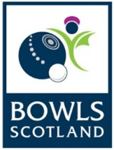
Trade Stand Application

National Championships

Monday 23rd – Saturday 28th July 2018
There are a limited number of trade stands available which will be allocated on a first come first serve basis. To secure your place please complete the application form and return by Thursday 31st May 2018.

Company Name:

Contact Name:

Address:

Post Code:

Telephone No:

Email address:

Company website:

Full description of products sold/services provided:

Size of retail space required:

Stand Requirements (eg table, chairs, electricity point):

Payment: Once your application has been approved, an invoice will be sent to you with the option to pay by BACS or cheque.

Please return application form by either post or email to:

Claire Johnston
Competitions & Events Officer
Bowls Scotland
National Centre for Bowling, Hunters Avenue
Ayr KA8 9AL

Telephone: 01292 294623

Email: candeofficer@bowlsscotland.com

