Child Protection
Resource Pack

[Blank page]
Contents

SECTION | CONTENT | PAGE
 | Introduction and Disclaimer | 3
SECTION 1 – Background | Legal Position  General Information | 4  4
SECTION 2 – Club Minimum Requirements | Registered Positions  Club Minimum Requirements  Job Description – Child Protection Officer  Job Description – Junior Coaches Assistant  Job Description – Junior Convenor  Template – Child Protection Policy  Guidance Document – Secondary Organisation Contract – Option 2  Secondary Organisation Contract – Option 2 (blank copy)  Template – Secure Handling Policy | 5  5  6  7  8  9  10-13  14-16  18
SECTION 3 – Registering your clubs Child Protection Officer | General Information  Training Courses  Member Club Child Protection Contact Information form | 20  20  22
SECTION 4 – Completing a PVG Scheme application form | PVG applications  PVG information for verifiers  Eligibility to Join the Scheme  Benefits of the PVG Scheme  Selecting the appropriate PVG check  Completing a PVG Scheme application form  Applicant Information – Application to Join the PVG Scheme  Application to Join the PVG Scheme – Quick Reference Guide  Sample Form – Application to Join the PVG Scheme  Applicant Information – Existing PVG Scheme Member Application  Existing PVG Scheme Member Application – Quick Reference Guide  Sample Form – Existing PVG Scheme Member Application | 24  24-26  26  27  28-29  30-34  35  36-37  38-40
SECTION 5 – Verification | Who verifies the ID of the Child Protection Officer?  Verifying other applicant’s identification  Child Protection Officer ID verification form  VSDS – Identity Verification Guidance Notes  Bowls Scotland PVG Application Coversheet | 41  41  42  44  46
SECTION 6 – PVG applicants – additional information required | Additional Information Required  Self Declaration Form  Code of Conduct for working with children  Voluntary Role – Application Form  Letter to Referees | 48  49-50  51-52  53-54  56
SECTION 7 – Other Relevant Information | Additional Information  Emergency Contact Numbers  Regulated work with protected adults  10 Steps to Safeguard Children in Sport  Club Partnership with parent / guardian  Template – Significant Incident Form  Checklist – Submitting a PVG Scheme Application Form  Club Child Protection Flowchart | 57  58  60-61  62-63  64  66

Introduction

Bowls Scotland has developed our Child Protection Resource Pack for clubs with support from Safeguarding in Sport (partnership between Children 1st and sportscotland) and guidance documents provided by Volunteer Scotland Disclosure Services (VSDS) and Disclosure Scotland.

The Child Protection Resource Pack has been designed to support clubs to put in place the necessary policies, processes and procedures for child protection and to act as a step-by-step guide for clubs in order to process PVG Scheme application forms. In 2012 Safeguarding in Sport produced the ’10 Steps to Safeguard Children in Sport’ resource which we have utilised to help create the Child Protection Resource Pack. The Bowls Scotland Child Protection Resource Pack does not replace the ’10 Steps the Safeguard Children in Sport’ they should be used in conjunction with one another.

Bowls Scotland’s Child Protection Resource Pack outlines the minimum requirements clubs have to meet before Bowls Scotland will register their Child Protection Officer and process Protection of Vulnerable Groups (PVG) applications on their behalf. The resource enables the club Child Protection Officer to verify identification for PVG applicants and submit PVG application forms to Bowls Scotland. In future this will ensure a more efficient and effective process for submitting PVG application forms for volunteers in our member clubs.

All information contained within the Child Protection Resource Pack is available to download from the Bowls Scotland website (www.bowlsscotland.com).

Disclaimer

Although every care has been taken by Bowls Scotland in the preparation of this publication, no warranty is given by Bowls Scotland as to the accuracy or completeness of the information contained within it. Bowls Scotland shall not be responsible or liable for any loss or damage whatsoever arising by virtue of such information or any instructions or advice within this publication or by any of the aforementioned.

SECTION 1 - Background

Legal Position

The Protection of Vulnerable Groups (Scotland) Act 2007 was passed by parliament and received Royal Assent in 2007. Following the introduction of the Act the Protection of Vulnerable Groups (PVG) Scheme was established in 2011 to replace and improve upon the disclosure arrangements for people doing regulated work with children and vulnerable adults.

“It is an offence for an organisation to offer regulated work to an individual barred from that type of work.”
(Protection of Vulnerable Groups (Scotland) Act 2007)

Therefore if a bowling club has a volunteer doing regulated work with children and they have not established whether or not that person is barred from working with children they may be committing an offence.

This document will help clubs to establish the correct policies, procedures and practices to fulfil their duty of care and ensure they are doing all they can to safeguard children taking part in lawn bowls in their club.

General Information

Bowls Scotland is registered with Volunteer Scotland Disclosure Services (VSDS) which enables us to process PVG applications for volunteers in our member clubs free of charge. Anyone whose role involves regulated work with children should join the PVG scheme.

In short, regulated work with children means that it is part of the person’s normal duties to teach, instruct, train or supervise children. For example, if you are a Club Coach and your duties involve delivering weekly bowls sessions with the local Primary School then you would be required to join the PVG Scheme. If however, your role in the club is the position of Club Secretary and you fill in on a one-off occasion to assist in a coaching session with children, then it is unlikely that regulated work with children is part of your normal duties.

To help ascertain whether or not one of your volunteers is fulfilling a regulated work role please use the guidance notes on pages 21-22.

If the volunteer fulfilling the regulated work role with children in your club already has a PVG Scheme membership for employment purposes or a voluntary role in another organisation they still require to be registered for the role they are fulfilling in your club. In this instance the volunteer should complete the Existing PVG Scheme Member Application.

SECTION 2 – Club Minimum Requirements

Registered Positions

Bowls Scotland has registered four roles with VSDS that have been identified as regulated work roles. We can process PVG applications for volunteers in clubs in any one of these roles.
- Child Protection Officer – providing advice to children
- Club Coach – instructing children (qualified bowls coach)
- Junior Coaches Assistant – instructing children (volunteers who do not hold an official coaching qualification but assist in sessions with children)
- Junior Convenor (coordinator for junior section)
Role descriptions for the positions of Child Protection Officer, Junior Coaches Assistant and Junior Convenor can be found on pages 6-8. These role descriptions are templates and can be adopted by clubs for their own use. There is no role description for Club Coach as this only applies to volunteers who have been through an official bowls coaching qualification.

If you have another role in your club which you believe is a regulated work role and isn’t covered by the positions above then please contact Bowls Scotland for further advice.

Club minimum requirements

Before Bowls Scotland can process a PVG application for a volunteer in your club there are three minimum requirements that the club must meet:
- Appoint a Child Protection Officer (CPO) – there is little time commitment involved in this role. The CPO is a point of contact in the club who understands the processes and procedures that should be followed for child protection. All children and parents should be aware who the CPO is and their contact details should be made available. Please note that the CPO does not have to be present at all times when children are in the club. There are two training courses offered by Local Authorities that the CPO should attend. More information on these courses is provided on page 20.
- Put in place a Child Protection Policy (see page 9)
- Complete a Secondary Organisation Contract (SOC) – this is a requirement of VSDS and is a contract between Bowls Scotland and the club outlining each organisations responsibility for Child Protection. This needs to be completed by the nominated Child Protection Officer. This should be completed electronically in the first instance and e-mailed to Bowls Scotland (development@bowlsscotland.com) for checking. The template contract can be found on pages 10-13 and the blank contract on pages 14-17.

For a simplified outline of the steps the club is required to take please view the Club Child Protection Flowchart on page 66.

[CLUB NAME]
Job Description – Child Protection Officer

Job Title: Child Protection Officer
Reports to: Management Committee

The Child Protection Officer has the main responsibility for managing child protection issues in [CLUB NAME]. The Child Protection Officer will be supported by [CLUB NAME] to ensure they are appropriately trained and supported to fulfil their role. The role and responsibilities of the Child Protection Officer are detailed below.

Skills required:

- Ability to communicate clearly and effectively
- Good listener
- Approachable with friendly manner
- Well organised
- Motivated
- Reliable
- Understanding and appreciation of the need for confidentiality

Key responsibilities:

- Act as the main contact within the club for the protection of children.
- Ensure all persons working with children at the club are fully aware of their responsibilities and are adequately trained and qualified for the role they are fulfilling.
- Be the first point of contact for coaches, helpers, parents and members on any issues concerning the well being of children in the club.
- Establish and maintain a Disciplinary and Complaints procedure and Child Protection Policy.
- Attend appropriate training courses including ‘In Safe Hands’ and ‘Safeguarding and Protecting Children’ (renewable every three years).
- Be familiar with current child protection legislation.
- In the event of a complaint being made ensure that the complaints procedures are met and see the procedures through to the final decision.
- Act as adviser, when required, to the Management Committee on matters of policy and procedures related to child protection.
- Encourage good practice and support of procedures to protect children.
- Maintain confidential records and ensure information is only held on an individual whilst the person continues to carry out their regulated work role within the club.
- Inform Bowls Scotland and Disclosure Scotland if you or any volunteers carrying out regulated work with children leave their roles.
- Ensure all incidents are correctly recorded and reported in accordance with the [CLUB NAME] policy and procedures.
- Seek advice from the appropriate agencies as and when required.
- Provide advice to children as and when necessary.

Time Commitment:

The estimated time commitment required as the Child Protection Officer is ..... hours per week. The Child Protection Officer is appointed for a one year period and will be elected at [CLUB NAME] AGM.
Job Description – Junior Coaches Assistant

JOB TITLE: Junior Coaches Assistant
RESPONSIBLE TO: Club Management Committee/Junior Convenor

SKILLS REQUIRED:
- Approachable and a good listener
- Well organised
- Able to work effectively as part of a team
- Confident and effective communicator
- Enthusiastic and a good motivator
- Prepared to make a regular time commitment

MAIN DUTIES:

- Organise training activities and coaching sessions for junior members

- Assist in the planning and delivery of junior bowls sessions

- Ensure a safe and secure environment for participants

- Help to arrange internal competitions for all juniors to ensure they have the opportunity to play in competitive matches

- Assume the duties of the Junior Convenor in their absence

- Motivate other volunteers through recognition and feedback

- Explore opportunities to link in with local schools and other partner organisations to increase participation in the junior section

- Link in with any national initiatives to increase participation in junior bowling

- Identify funding opportunities to help ensure the continued growth of the junior section

- Assist in the organisation of fundraising activities for the junior section

- Comply with the clubs Child Protection Policy and procedures

- Assist the Junior Convenor in monitoring and evaluating the success of the junior section
TIME COMMITMENT: ………………………………………………………………………………………
SIGNATURES: Chair Person …………………………………………………………………... Date…………………………………………………………………...
Secretary …………………………………………………………………...
Date…………………………………………………………………...

Job Description – Junior Convenor

JOB TITLE: Junior Convenor
RESPONSIBLE TO: Club Management Committee
SKILLS REQUIRED:
- Approachable and a good listener
- Well organised
- Able to delegate
- Able to work effectively as part of a team
- Confident and effective communicator
- Enthusiastic and a good motivator
- Prepared to make a regular time commitment
MAIN DUTIES:
- Organise training activities and coaching sessions for junior members

- Lead the delivery and planning of junior bowls sessions

- Arrange internal competitions for all juniors to ensure they have the opportunity to play in competitive matches

- Where possible, arrange friendly matches and take part in external junior competitions to give the juniors exposure to competing in teams and playing on other bowling greens

- Coordinate the transportation of children to matches

- Act as the main contact for all parents

- Promote suitable training opportunities for all coaches and volunteers

- Ensure those carrying out regulated work with children have PVG Scheme membership and that all appropriate checks or updates are made

- Ensure that each volunteer understands their job and their role within the club

- Ensure that all roles within the junior section have a job description – consult volunteers and Management Committee to update job descriptions when appropriate

- Motivate volunteers through recognition and feedback

- Explore opportunities to link in with local schools and other partner organisations to increase participation in the junior section

- Link in with any national initiatives to increase participation in junior bowling

- Identify funding opportunities to help ensure the continued growth of the junior section and organise fundraising activities

- Comply with the clubs Child Protection Policy and procedures

- Annually monitor and evaluate the success of the junior section and make key recommendations to the Management Committee to continually improve the service offered to junior members
TIME COMMITMENT: ………………………………………………………………………………………
SIGNATURES: Chair Person …………………………………………………………………... Date…………………………………………………………………...
Secretary …………………………………………………………………...
Date…………………………………………………………………...
[Club Name] Bowling Club
Child Protection Policy

[Club name] Bowling Club is fully committed to safeguarding the welfare of all children in its care. It recognises the responsibility to promote safe practice and to protect children from harm, abuse and exploitation. For the purposes of this policy and associated procedures a child is recognised as someone under the age of 18 years.

Staff and volunteers will work together to embrace difference and diversity and respect the rights of children and young people.

This document outlines [Club name] Bowling Club’s commitment to protecting children.

This policy is based on the following principles:
- The welfare of children is the primary concern.
- All children, whatever their age, culture, disability, gender, language, racial origin, socio-economic status, religious belief and/or sexual identity have the right to protection from all forms of harm and abuse.
- Child protection is everyone’s responsibility.
- Children have the right to express views on all matters which affect them, should they wish to do so.
- Organisations shall work in partnership together with children and parents/carers to promote the welfare, health and development of children.

[Club name] Bowling Club will:
- Promote the health and welfare of children by providing opportunities for them to take part in bowls safely.
- Respect and promote the rights, wishes and feelings of children.
- Promote and implement appropriate procedures to safeguard the well-being of children and protect them from abuse.
- Recruit, train, support and supervise its staff, members and volunteers to adopt best practice to safeguard and protect children from abuse and to reduce risk to themselves.
- Require staff, members and volunteers to adopt and abide by this Child Protection Policy and associated procedures.
- Respond to any allegations of misconduct or abuse of children in line with this Policy and associated procedures as well as implementing, where appropriate, the relevant disciplinary and appeals procedures.
- Observe guidelines issued by local Child Protection Committees for the protection of children.
- Regularly monitor and evaluate the implementation of this Policy and the associated procedures.

Review

This Policy and associated procedures will be regularly reviewed:
- In accordance with changes in legislation and guidance on the protection of children or following any changes within [Club name] Bowling Club.
- Following any issues or concerns raised about the protection of children within [Club name] Bowling Club.
- In all other circumstances, at least every three years.

Secondary Organisation Contract – Guidance
This contract form should be used when a secondary organisation requires the intermediary body to access and manage the disclosure records that have been accessed on their behalf and pass the details to the secondary organisation.

Introduction – What is Volunteer Scotland Disclosure Services?
Volunteer Scotland Disclosure Services is a service which has been operated by Volunteer Scotland since 2002.
Volunteer Scotland Disclosure Services manages the essential service of providing free disclosure records, guidance, advice and support to voluntary sector organisations working with children, young people and protected adults.
What is an intermediary body (the organisation who will act on your behalf)?
- An intermediary body is an organisation that is enrolled with Volunteer Scotland Disclosure Services and is able to access disclosure records on behalf of other not for profit voluntary sector organisations.

- Intermediary bodies in general represent their own affiliated groups/clubs, managing the disclosure process and decisions relevant to the disclosure process for them. Some intermediary bodies however represent small organisations/groups that have no affiliation to them.

- Organisations and groups accessing disclosure records through an intermediary body are called secondary organisations.

Guidance
Part 1 – to be completed by the Secondary Organisation
Lawra Cox
Name of Intermediary Body
Lead Person:

Insert Bowling Club Name

Name of secondary
organisation/group requiring
disclosure records:

Name of person within the secondary organisation who will receive information relative to Scheme Records and Scheme Record Updates from the intermediary body through written or oral communication:

Contact Person (Child Protection Officer)

Address of Secondary Organisation:

Bowling Club Address

Tel no: Email:
Email Address

Contact Telephone Number

Tel no: Email:
Is the Secondary Organisation a qualifying voluntary organisation Yes No
A qualifying voluntary organisation is an organisation which:
- Is not conducted primarily for profit, and any profit generated is used to further the objectives of the organisation and is not distributed to its members
- Is not a further education institution, a school, a public or local authority, or which is not under the management of a public or local authority.

How is funding generated for your organisation e.g. (from specific organisations, grants or by fundraising within your organisation?)
Please include details of any funding generated by your organisation

Companies House No.

Are you a registered care service? Yes No If yes, enter details below

Type of care service Registration No.
(Taken from Care Inspectorate registration (if relevant)

Is your organisation a registered charity? Yes No If yes, enter details below

Registered Charity No.
Please provide a brief description of the purpose of your organisation and detail the reasons for your entitlement to obtain disclosure records.
We are an equitable club who promote the sport of lawn bowls and provide membership to all in the community. Our club coaches and junior coaches assistants will be delivering bowls coaching sessions to children on the outdoor bowling greens.

Which positions will you require the individual to obtain a Scheme Record or Scheme Record Update?
Position | Level | Child/Adult/Both
Club Coach | PVG | Children
Junior Coaches Assistant | PVG | Children
Child Protection Officer | PVG | Children

I understand that it is the responsibility of
Bowls Scotland

to have responsibility for

- ensuring the Ministerial Code of Practice is implemented at all times when submitting Scheme Record or Existing PVG Scheme Member applications by my organisation,

- ensuring Scheme Record or Existing PVG Scheme Member applications submitted by my organisation are completed correctly;

- ensuring my organisation understands its obligations and completes and signs up to a secondary organisation contract of agreement with the Intermediary Body.

Will the Intermediary Body forward the Disclosure Certificate to your organisation Yes No
x

How and when will you record the information/certificate passed to you in relation to the Scheme Record and Short Scheme Record by the Intermediary Body? (Please be aware that Disclosure Certificates are governed by the PVG Code of Practice whilst any tracking sheet is governed by Data Protection legislation.
Information will be stored within a secure locker only accessible to the CPO. The information will only be held for as long as the individual continues to fulfil their regulated work role.

Does your organisation have a policy on the storage of the information? Yes No

Declaration
Do you agree that the information received will not be disclosed to any other

persons other than those entitled to see it in the course of their official duties? Yes No

Have you read and understood the Code of Practice published by Scottish

Ministers giving information on how the PVG scheme should be operated? Yes No

Do you understand that unauthorised disclosure of information on a Scheme
Record or Short Scheme Record is a criminal act? Yes No

Do you understand that having a criminal record should not necessarily

debar an ex offender from a position? Yes No

Do you understand that you must inform the Intermediary Body if you leave Yes No

your position or no longer wish to act as the nominated person for receiving
disclosure records?

Are you aware that you can be contacted by the Volunteer Scotland Yes No

Disclosure Services or Disclosure Scotland regarding any matters that relate
to the compliance of the relevant legislation at any time?

Do you understand that you cannot use the information which appears on Yes No

a Scheme Record or Short Scheme Record for any purpose other than
those for which it has been provided?

Do you understand that the Intermediary Organisation can carry out an audit Yes No

on an annual basis.

Will the Intermediary Organisation act in an advisory capacity to support your Yes No

Organisation to make a recruitment decision.

I certify that all information contained in this form is true and correct to the best of my knowledge and realize that false information or omissions may lead to an investigation from Volunteer Scotland Disclosure Services and/or Disclosure Scotland.

Signature: __________________________________ Date: ______________

Part 2 – to be completed by the Intermediary Body

Enrolled Body Code: AA___________

Signatory Name: _______________________________________

Signature: __________________________ Date: ______________

Secondary Organisations Contract

This form should be completed when a Secondary Organisation requires the Intermediary Body to access and manage the disclosure records that have been accessed on their behalf and pass the details to the secondary organisation through written or oral communication.

Part 1 – to be completed by the Secondary Organisation

Name of Intermediary Body:

Name of Secondary

Organisation:

Name of person within the Secondary Organisation who will receive information relative to Disclosure Records and Disclosure Record Updates from the intermediary body through written or oral communication:

Address of Secondary Organisation:

Tel no: Email:

Tel no: Email:

Is the Secondary Organisation a qualifying voluntary organisation Yes No

A qualifying voluntary organisation is an organisation which:

- Is not conducted primarily for profit, and any profit generated is used to further the objectives of the organisation and is not distributed to its members
- Is not a further education institution, a school, a public or local authority, or which is not under the management of a public or local authority.

How is funding generated for your organisation e.g. (from specific organisations, grants or by fundraising within your organisation?)

Companies House No.

Are you a registered care service? Yes No If yes, enter details below

Type of care service Registration No.

Registered Charity No.

Please provide a brief description of the purpose of your organisation and detail the reasons for your entitlement to obtain disclosure records.

Which positions will you require the individual to obtain a Scheme Record or Scheme Record Update?
Position | Level | Child/Adult/Both
e.g. Coach | PVG | Children

I understand that it is the responsibility of
Insert name of Intermediary Organisation

to have responsibility for:

- ensuring the Ministerial Code of Practice is implemented at all times when submitting Scheme Record or Existing PVG Scheme Member applications by my organisation,

- ensuring Scheme Record or Existing PVG Scheme Member applications submitted by my organisation are completed correctly;

- ensuring my organisation understands its obligations and completes and signs up to a secondary organisation contract of agreement with the Intermediary Body.

Will the Intermediary Body forward the Disclosure Certificate to your organisation Yes No

How and when will you record the information/certificate passed to you in relation to the Scheme Record and Short Scheme Record by the Intermediary Body? (Please be aware that Disclosure Certificates are governed by the PVG Code of Practice whilst any tracking sheet is governed by Data Protection legislation.)

Does your organisation have a policy on the storage of the information? Yes No

Declaration
Do you agree that the information received will not be disclosed to any other

persons other than those entitled to see it in the course of their official duties? Yes No

Have you read and understood the Code of Practice published by Scottish

Ministers giving information on how the PVG scheme should be operated? Yes No

Do you understand that unauthorised disclosure of information on a Scheme
Record or Short Scheme Record is a criminal act? Yes No

Do you understand that having a criminal record should not necessarily

debar an ex offender from a position? Yes No

Do you understand that you must inform the Intermediary Body if you leave Yes No

your position or no longer wish to act as the nominated person for receiving

disclosure records?

Are you aware that you can be contacted by the Volunteer Scotland Yes No

Disclosure Services or Disclosure Scotland regarding any matters that relate

to the compliance of the relevant legislation at any time?

Do you understand that you cannot use the information which appears on Yes No

a Scheme Record or Short Scheme Record for any purpose other than

those for which it has been provided?

Do you understand that the Intermediary Organisation can carry out an audit Yes No

on an annual basis.

Will the Intermediary Organisation act in an advisory capacity to support your Yes No

Organisation to make a recruitment decision.

I certify that all information contained in this form is true and correct to the best of my knowledge and realize that false information or omissions may lead to an investigation from Volunteer Scotland Disclosure Services and/or Disclosure Scotland.

Signature: __________________________________ Date: ______________

Part 2 – to be completed by the Intermediary Body

Enrolled Body Code: AA___________

Signatory Name: _______________________________________

Signature: __________________________ Date: ______________

[LOGO]
[CLUB NAME]
Secure Handling, Use, Storage and Retention of Disclosure Information
For the purpose of this policy, PVG Scheme Records, PVG Scheme Record Updates, Standard and Enhanced disclosures will be referred to as Disclosure Records.
This policy is for Scottish bowling clubs who are affiliated to Bowls Scotland and are accessing Disclosure Records through Volunteer Scotland Disclosure Services (VSDS) for the purpose of assessing individual’s suitability for unpaid work.
In accordance with the Scottish Government Code of Practice, for registered persons and other recipients of disclosure information, [CLUB NAME] will ensure the following practice.
Disclosure records will only be requested when necessary and relevant to a particular post and the information provided on a disclosure record will only be used for recruitment purposes.
[CLUB NAME] will ensure that an individual’s consent is given before seeking a disclosure record, and will seek their consent before using disclosure information for any purpose other than recruitment. Furthermore, [CLUB NAME] will ensure that all sensitive personal information that is collated for the purposes of obtaining a record will be managed confidentially at all times by those involved in the Disclosure process.
Disclosure information will only be shared with those authorised to see it in the course of their duties.
Disclosure information will be stored in a locked non-portable container and we will not retain such information for longer than it is relevant to our needs. Only those authorised to see this information in the course of their duties will have access to this container. Disclosure information will be destroyed by shredding. No image or photocopy of the disclosure information may be retained. Recipients of disclosure information may, however, keep a record of the following:
- Date of issue of disclosure record
- Name of subject
- Disclosure type
- Position for which the disclosure was requested
- Unique reference number of disclosure
- Recruitment decision taken

[CLUB NAME] will ensure that all officers with access to disclosure information are aware of this policy and have received relevant training and support. [CLUB NAME] undertakes to make a copy of this policy available to any applicant for a post with [CLUB NAME] that requires a Disclosure.

[Blank Page]

SECTION 3 – Registering your club’s Child Protection Officer

General Information

Once your club has identified a Child Protection Officer (CPO) you can work towards meeting the minimum requirements for being able to process PVG application forms, however, your CPO still needs to be fully registered with Bowls Scotland.

In order for Bowls Scotland to register your CPO they are required to attend two training courses and complete a PVG Scheme application form (Section 4) for their role in your club. The CPO’s role description will include ‘providing advice to children’ and therefore can be determined as a regulated work with children role.

The first training course the CPO needs to attend is ‘Safeguarding & Protecting Children’ or another basic child protection awareness workshop. Once they have completed the first course they should attend ‘In Safe Hands’ which is a specific club Child Protection Officer workshop.

Training Courses

Safeguarding & Protecting Children, sportscoach UK workshop (SPC)
This 3-hour workshop is suitable for coaches and volunteers who may come in to contact with children. This workshop explores the Code of Conduct for those in contact with children and provides basic information on recognising child abuse and responding to concerns. It is recommended that all coaches and volunteers working with children and young people attend this workshop.

Other basic child protection awareness workshops available in Scotland
Throughout Scotland, local Child Protection Committees organise and offer free training to the voluntary sector working with local children and young people. To find out how to get in touch with your local Child Protection Committee please visit the Children 1st website (www.children1st.org.uk). The content of these workshops will be similar to that of ‘Safeguarding & Protecting Children’.

Safeguarding & Protecting Children 2, sportscoach UK workshop (SPC 2)
This 3-hour workshop reflects on practice, is aimed primarily at coaches and builds on knowledge gained on the ‘Safeguarding & Protecting Children’ workshop (SPC). Outcomes for delegates include increasing awareness, helping recognise the signs of abuse and poor practice and helping to deal sensitively and effectively with issues that arise. In order to keep knowledge up-to-date in this area, it is recommended that individuals first attend the SPC workshop and follow this up with SPC 2 every two to three years.

In Safe Hands: Club Child Protection Officer Workshop
This 3 hour workshop supports clubs to put child protection policies into practice. It is most suitable for those acting as the club child protection officer but is also relevant for those responsible for managing or organising the club.

For dates, times and venues of the above courses please contact your local authority Sports Development team or visit one of the following websites.

http://www.bowlsscotland.com

http://www.children1st.org.uk/what-we-do/our-services/search-our-services/safeguarding-in-sport/training/

http://www.sportscotland.org.uk/events/index

[Blank page]

MEMBER CLUB CHILD PROTECTION
CONTACT INFORMATION

CLUB NAME:

We confirm that our named Child Protection Officer has attended the ‘Safeguarding & Protecting Children’ and ‘In Safe Hands’ child protection courses and has had the relevant Disclosure Scotland checks made to confirm they are an appropriate person to be carrying out regulated work with children.
(this declaration should be signed by a member of the club’s Management Committee or Board)

Signed:

Print name:

Position:

Date: / /

CLUB CHILD PROTECTION OFFICER:

Name: Phone:

Address: Mobile:

Town/ City: Postcode:

E-mail:

I confirm that I have completed a PVG Scheme application form for the regulated work role I will be fulfilling in the club and have received a certificate from Disclosure Scotland confirming I am a suitable individual to fulfil this role.
Signed (CPO): Date:

Child Protection training courses:

Safeguarding and Protecting Children (or other child protection general awareness course):

Date attended: / / Venue:

In Safe Hands:

Date attended: / / Venue:

If there are any changes to the information above then please inform Bowls Scotland immediately. This information is only for use by Bowls Scotland and will not be passed to any other organisations.

Please return the completed form to Bowls Scotland, National Centre for Bowling, Hunters Avenue, Ayr, KA8 9AL (e-mail: development@bowlsscotland.com) and retain a copy for your own club records.

[blank page]
SECTION 4 – Completing a PVG Scheme application form

PVG applications

Once your club has met the three minimum requirements you can begin processing PVG applications for volunteers in your club. On page 57 you will find a checklist for reference when submitting a PVG Scheme application form to Bowls Scotland.

All Child Protection Officers registered with Bowls Scotland are able to act as a verifier for volunteers in their club. The verifier will ensure that the applicant completes the form correctly and they will carry out the appropriate ID checks on each applicant. Once the checks are completed they will submit the completed PVG application forms along with the PVG application coversheet to Bowls Scotland.

To request ‘Application to Join the PVG Scheme’ or ‘Existing PVG Scheme Member’ forms please contact the Bowls Scotland Head Office on 01292 294 623 or development@bowlsscotland.com. Before contacting Bowls Scotland please determine whether or not your volunteers are already members of the PVG Scheme to ensure you are sent the correct forms. If they are already a member of the PVG Scheme (introduced 2011) they will have a PVG Scheme membership number.

PVG Scheme information for verifiers

The Protection of Vulnerable Groups (Scotland) Act 2007 introduced the PVG Scheme for those in regulated work with children and protected adults. This law applies to organisations and groups across the statutory, voluntary and private sectors that provide services and activities for children, young people and / or protected adults. For the majority of sports clubs/ sports organisations/ and Sport Governing Bodies the PVG Scheme will relate to work with children and young people and rarely involve work with protected adults. Disclosure Scotland holds a Children’s List and an Adult’s List of individuals barred from regulated work with children and/or protected adults.

Eligibility to Join the Scheme
- People doing certain types of work in Scotland, known as regulated work, with children, young people and/or protected adults can apply to join the PVG Scheme e.g. Club Coach who coaches children.
- By way of a summary regulated work is defined by four basic principles:
  - It has to be work, (paid or unpaid) i.e. not simply an arrangement between friends/family.
  - It has to be with either children/young people, (or protected adults)
  - It has to be part of normal duties i.e. the activity is reasonably anticipated and could appear on the person’s job description
  - The work has to include:
    - Caring for children/young people
    - Teaching, instructing, training or supervising children/young people
    - Being in sole charge of children/ young people
    - Having unsupervised access to children/young people
- The role of managing a person in regulated work is also considered to meet the definition of regulated work, e.g. a youth section convenor.
- On first application for membership to the Scheme, the checks will be carried out by Disclosure Scotland. Unless these checks uncover information which makes the applicant unsuitable to work with one or both of the above groups the applicant will become a Scheme Member.
- It is an offence for someone who is barred from regulated work to do or seek to do that type of regulated work. It is an offence for an organisation to employ an individual in regulated work if they are barred.
Benefits of the PVG Scheme
- Continuous updating – Individual records held by the PVG Scheme will be updated automatically if new vetting information (i.e. convictions and other information held by the police) becomes known, or when a person’s circumstances change. This replaces the need for a person to have multiple disclosure certificates and makes it easier for clubs and sports organisations to check on an individual’s suitability to do regulated work.
- Effective Barring – In a change to the old system the PVG Scheme doesn’t just collect and disclose vetting information. It also assesses it, so that individuals who are considered unsuitable on the basis of vetting information are prevented from entering the workforce, or can quickly be removed from the workforce if new information arises which makes them unsuitable.
Selecting the appropriate PVG check
- This is dependent on whether the person is an existing Scheme Member (e.g. has already joined the PVG Scheme for a regulated work role within another sports clubs) or is yet to join the PVG Scheme. The table below outlines the three PVG checks, the purpose of each and what information is provided on each record/statement.
- Scottish Ministers have waived the fees for the PVG checks for volunteers doing unpaid; regulated work in the voluntary sector in Scotland. This includes sports clubs/organisations.
- There are fees for PVG checks for employees doing paid regulated work (e.g. members of staff within a club). If your club requires a check for a paid member of staff then they should contact Disclosure Scotland directly.
- Once a PVG application has been submitted and processed the individual will receive their Scheme Record and a copy will also be sent to the Lead Officer for Child Protection within Bowls Scotland.
Type of PVG Scheme Check | Purpose | Information Provided by Disclosure Scotland
- Scheme Record (a quick reference guide to completing this application form can be found on pages 25-26) | When a person joins the PVG Scheme for the first time to work for a club/organisation or when a club/organisation requires a full PVG Scheme Record to ascertain the detail of new vetting information highlighted in a Scheme Record Update. | - Confirm that the person is a PVG Scheme member  - Include all vetting information (criminal history information and information that the police consider relevant to the type of regulated work)  - Indicate whether the person is under consideration for listing (e.g. there’s a possibility they may be added to the barred from working with children list and/ or protected adults)
- Scheme Record Update (a quick reference guide to completing this application form can be found on pages 33-34) | When a person is an existing PVG Scheme member and a club/organisation is recruiting the individual. | - Confirm that the person is a PVG Scheme member  - Specify the date of disclosure of the last PVG Scheme Record  - State whether any existing vetting information was included in the member’s PVG Scheme Record on the date it was last issued  - Indicate whether any new vetting information has been added to the member’s PVG Scheme Record and the date each item was added (without detailing the substance of any such vetting information)  - Indicate whether the person is under consideration for listing
- Scheme Membership Statement | For self-employed people or people seeking to work with vulnerable groups to confirm that they are members of the PVG Scheme and not barred from regulated work. | - Confirm that the person is a PVG Scheme member  - Indicate whether the individual is under consideration for listing

Completing a PVG Scheme application form

Detailed guidance notes for completing an ‘Application to Join the PVG Scheme’ and ‘Existing PVG Scheme Member Application’ can be downloaded from the Volunteer Scotland (www.volunteerscotland.net/disclosure-services) website. The Quick Reference Guidance Notes issued by Bowls Scotland (pages 28-29 and 36-37) should provide you with all the guidance required for completing the forms for an applicant in a bowling club.

The following key points will help you to ensure that applicants have completed their forms correctly.

Key Points

DO
- Complete all sections of the form.
- Complete all fields unless guidance notes suggest otherwise. Mandatory fields are highlighted in yellow.
- We recommend you use blue or black ink to complete the form and write clearly in BLOCK CAPITALS.
- Use only one letter or number for each box. The number of boxes given for each section indicates the maximum amount of letters / numbers that the system will accept.
- Please indicate a space by leaving an empty box
e.g. 1 Tower Court should be entered 1 TOWER COURT.
- Mark choices in the boxes indicated with an ‘X’.
- Be sure to sign the declaration at Part C, keeping your entire signature inside the box.
- If you make a mistake please correct it by either using the correcting fluid sparingly, or by clearly scoring through the error and by writing the answer in the remaining space. If this is not possible, please start a new form.
- Only complete the sections that are applicable to you. Don’t mark any other part of the form.

DON’T
- Write over the edge of the boxes.
- Place any stamps or stickers on the form, (e.g. those featuring addresses) or the application will be returned.

Applicant Information – Application to Join the PVG Scheme

The following information should be read by all applicants completing an ‘Application to Join the PVG Scheme’.

When you complete this form, it will contain personal information about you. For that reason, it is marked PROTECT – PERSONAL (WHEN COMPLETED). This marking means that both VSDS and Disclosure Scotland staff will handle the completed form appropriately and therefore protect your personal information. VSDS and Disclosure Scotland takes the protection of your personal information extremely seriously and has many physical technical and procedural measures in place to ensure that it cannot be accessed or used for anything other than the purposes for which it is needed. In particular, information is only shared with external sources for specific purposes. We will never share your personal information with any other organisation without your prior consent.

Introduction

This is the form for applying to join the Scheme under the Protection of Vulnerable Groups (Scotland) Act 2007 - called the PVG Scheme. You should use this form only if you are joining the Scheme for the first time. If you are already a member of the Scheme for one type of regulated work (e.g. with children) and want to expand your membership to include the other type of regulated work (with protected adults), you should use the Existing Scheme Member Application.

When you sign the form to apply to join the PVG Scheme, you are confirming that-

  - you are not barred from the type(s) of regulated work to which your application relates (it is a criminal offence to seek to do regulated work while barred); and
  - you are applying to join the PVG Scheme for lawful purposes, usually that you are seeking to do the type(s) of regulated work to which the application relates.

Once you become a member of the PVG Scheme –

- Disclosure Scotland will continuously update the records they hold about you so that any new vetting information (e.g. convictions) will be added to your record as it becomes available.
- Disclosure Scotland will notify all organisations for whom you are doing regulated work if you are placed under consideration for listing or become barred.
- You must notify Disclosure Scotland of any change in your name or gender within three months of the change taking place.
- You should notify Disclosure Scotland when you cease to do regulated work for an organisation. Failure to do so may lead to that organisation receiving notifications of any future consideration for listing or barring to which you may become subject.
- You should take due care of your PVG Scheme membership number and any disclosure records or other documentation issued to you by Disclosure Scotland.

FAQ’s

- Does the legislation state I need to be a PVG Scheme member to work with children?

No. It is not a legal requirement for you. However, it is a legal requirement of the club to ensure that they do not employ an individual (paid or unpaid) who is on the Children’s List and therefore barred from working with children. That is why they are asking you to become a PVG Scheme Member. This is the only way they can check you are not barred. The club needs to ensure that they are safeguarding the children in their club to the best of their ability.

- What if I have previous convictions/non-conviction information?

Having a criminal record will not necessarily prevent you from working in the club. Any relevant vetting information disclosed on your Scheme Record will be considered in relation to the position you have applied for. By disclosing this information in the self-declaration form, you will have had the opportunity already to make Bowls Scotland aware of this information and provide some details. If required, we will invite you to a meeting to discuss this further to ensure we have as much of an understanding as possible with regards to your situation.
Application to Join the PVG Scheme – Quick Reference Guide

This form should be completed by any applicants who are not already a member of the PVG Scheme and are going to be fulfilling a regulated work with children role in your club.

Anyone who has an existing Enhanced Disclosure (prior to February 2011) for a regulated work with children role that they are still fulfilling in your club should complete an application to join the PVG Scheme form.

The full guidance notes issued by Volunteer Scotland Disclosure Services can be downloaded from the VSDS (www.VSDS.org.uk) or Bowls Scotland website (www.bowlsscotland.com).

A SAMPLE ‘APPLICATION TO JOIN THE PVG SCHEME’ IS PROVIDED ON PAGES 27-31.

Quick Reference Guide – First time applicants
- We recommend you use blue or black ink to complete the form and write clearly in BLOCK CAPITALS.
- Mark choices in the boxes indicated with an ‘X’.
- Only complete the sections that are applicable to you. Don’t mark any other part of the form.

PART A

A1 Mark a cross in the box beside ‘Scheme Record’.
A2 Mark a cross in the box beside ‘Children’.
A3 Mark a cross at ‘No’.

PART B

B1 Mark a cross beside your title. If other please complete details in boxes provided.
B2 Fill in your surname.
B3 Fill in your first name and any middle names.
B5 Mark a cross beside ‘Yes’ or ‘No’
If ‘Yes’ please complete B6-B12 with details of previous names.
B13 Fill in Mother’s Maiden or Family Name. This should only be the surname.
B14-B18 Fill in birth details.
B19-B22 Fill in contact details (you must insert at least a contact phone number).
B23 Mark a cross beside ‘Yes’ or ‘No’
If ‘Yes’ please complete B24.
B25 Mark a cross beside ‘Yes’ or ‘No’
If ‘Yes’ please complete B26 and B27. For UK residents your Passport number is in the top right hand corner of your photo page. If your Passport was issued in the UK you should insert United Kingdom at B27.
B28 Mark a cross beside ‘Yes’ or ‘No’
If ‘Yes’ please complete B29 and B30. For UK residents your Driving Licence number will start with the first five letters of your surname. If your Driving Licence was issued in the UK you should insert United Kingdom at B30.
B31 Mark a cross beside ‘Yes’ or ‘No’. For UK residents this will be ‘No’.
If ‘Yes’ please complete B32 and B33.
B34 If the applicant is using their National Entitlement Card for identification then they should fill in the 16 digit number.
B35 If the applicant is using an Electricity Bill as identification they should fill in their Electricity Supplier number here (21 digits).
B36 Mark a cross beside ‘No’. If the applicant believes they are already a PVG Scheme member they should be completing an ‘Existing PVG Scheme Member Application’.
B38 Mark a cross beside ‘Yes’ or ‘No’. ISA stands for Independent Safeguarding Authority (equivalent organisation of Disclosure Scotland in England and Wales).
If ‘Yes’ please complete B39.
B40-B46 Fill in current address details. At B45 you should enter how long you have been resident at your current address for in the following format MM/YYYY (e.g. 01/2013).
B47-B82 If you have lived at your current address for less than five years then please complete this section until you have provided five years worth of address history. You should start with your most recent address first.
B83 Mark a cross beside ‘Yes’ or ‘No’. If ‘Yes’ please complete sections B84-B87. For a list of Regulatory Bodies please turn to the next page.

Regulatory Bodies

Regulatory Body Name | Regulatory Body Code
Care Commission* | 101
General Chiropractic Council | 102
General Dental Council | 103
General Mental Council | 104
General Optical Council | 105
General Osteopathic Council | 106
General Teaching Council for Scotland | 107
Health Professions Council | 108
Nursery and Midwifery Council | 109
Royal Pharmaceutical Society of Great Britain | 110
Scottish Social Services Council | 111
*Also known as the Scottish Commission for the Regulation of Care.
If you are registered with the General Teaching Council for Scotland or Scottish Social Services Council and you include your registration number and you are applying for a Scheme Record, then a duplicate of your Scheme Record will be sent to the GTSC or SSSC, as appropriate.

If you are applying for registration at the same time as you are applying for Scheme membership and do not yet have a registration number then you should answer B83 ‘No’ and let Disclosure Scotland have the relevant details at a later date, once you have completed the registration process.

PART C

C1-C2 Please read the declaration then sign within the box and date in the following format DD/MM/YYYY.

PART D

D1 Mark a cross beside ‘Yes’. If you are completing an application for a paid position in your club then please contact Disclosure Scotland directly.

PART E

E1 Mark a cross beside ‘Yes’ or ‘No’. If they are new to the role they should mark ‘No’. If they have already been fulfilling the role and have an Enhanced Disclosure for this position then they should cross ‘Yes’.
E2 Mark a cross beside ‘Yes’ or ‘No’. For all positions within the bowling club this will be ‘No’.
E3 Fill in the full name of the bowling club e.g. SCOTLAND BOWLING CLUB.
E5 Fill in the name of the role that the volunteer will be fulfilling. In must be one of the four following registered positions:
- CHILD PROTECTION OFFICER – PROVIDING ADVICE TO CHILDREN
- CLUB COACH (this is a qualified coach)
- JUNIOR COACHES ASSISTANT – INSTRUCTING CHILDREN (this is an unqualified coach)
- JUNIOR CONVENOR – INSTRUCTING CHILDREN
E7-E14 DO NOT COMPLETE ANY INFORMATION IN THIS SECTION
E15 Mark a cross beside ‘Yes’.
E16 Fill in the full name of the bowling club e.g. SCOTLAND BOWLING CLUB.

DO NOT COMPLETE PART F OR PART G.
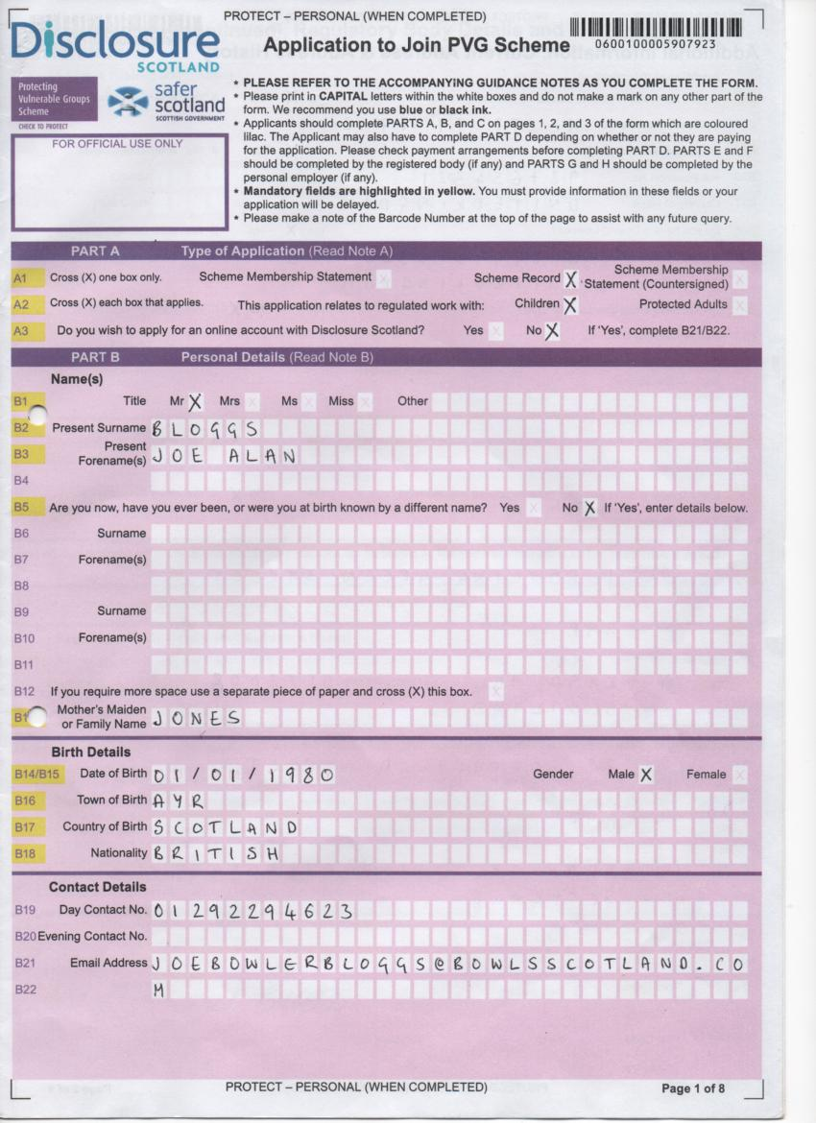
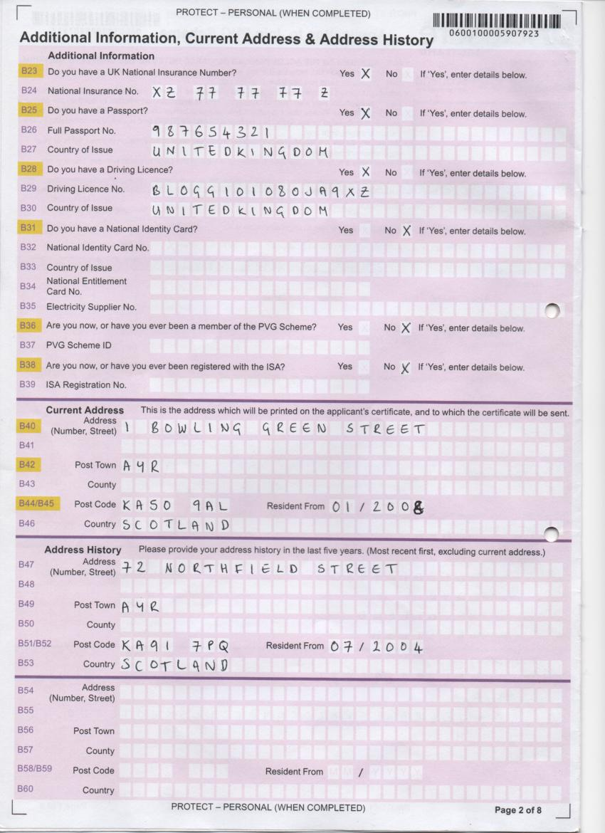
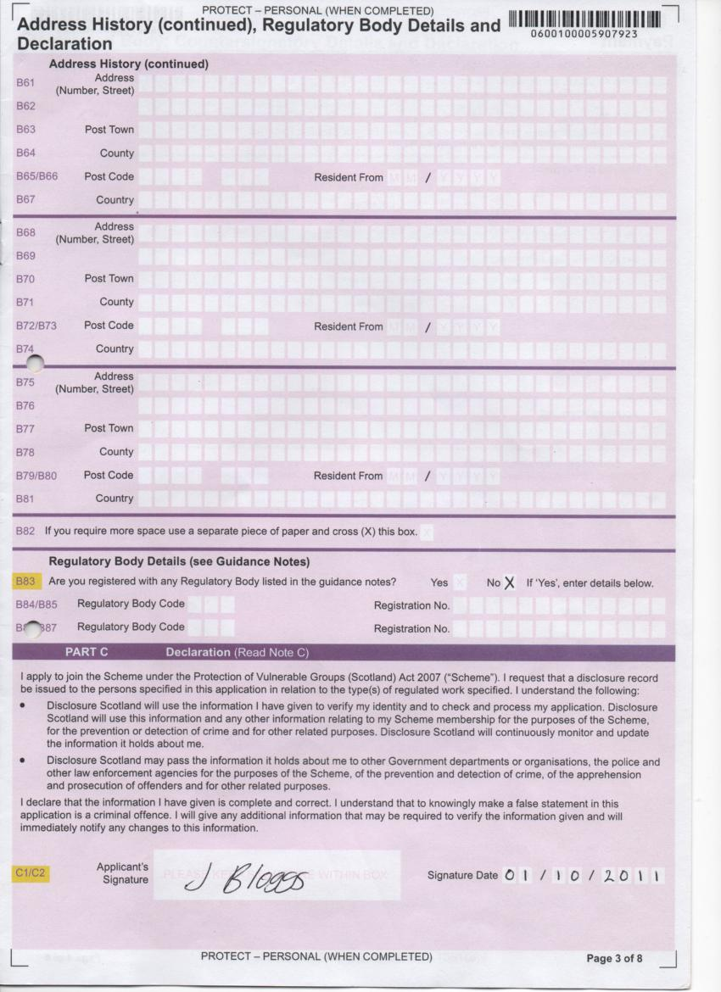
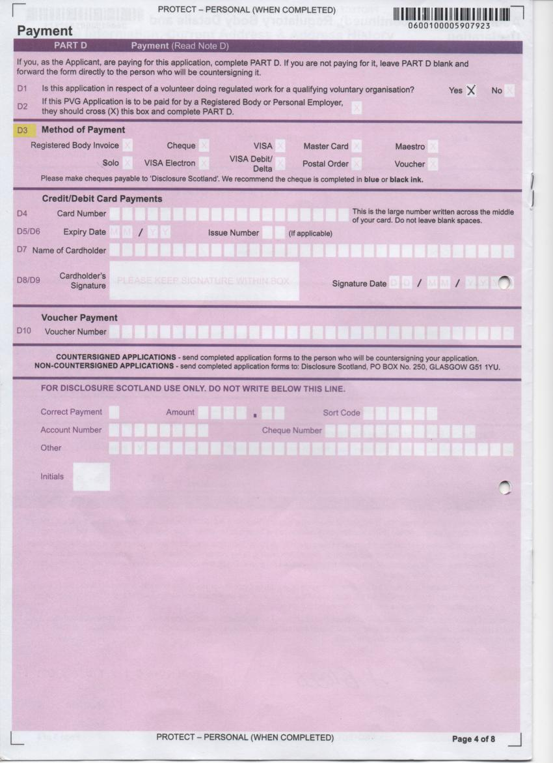
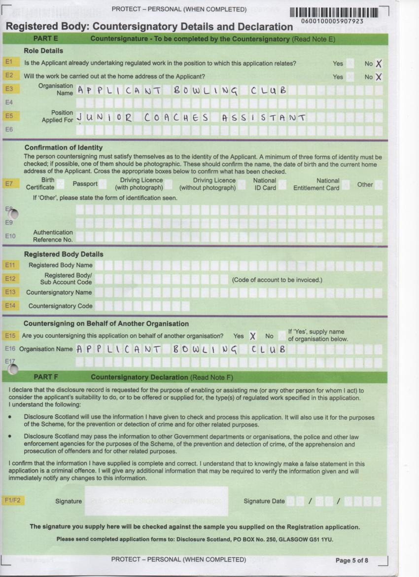
Applicant Information – Existing PVG Scheme Member Application

The following information should be read by all applicants completing an ‘Existing PVG Scheme Member Application’.

When you complete this form, it will contain personal information about you. For that reason, it is marked PROTECT – PERSONAL (WHEN COMPLETED). This marking means that both VSDS and Disclosure Scotland staff will handle the completed form appropriately and therefore protect your personal information. VSDS and Disclosure Scotland takes the protection of your personal information extremely seriously and has many physical, technical and procedural and measures in place to ensure that it cannot be accessed or used for anything other than the purposes for which it is needed. In particular, information is only shared with external sources for specific purposes. We will never share your personal information with any other organisation without your prior consent.

Introduction

You should use this form if you are already a member of the PVG Scheme and require and update for a new or current position in regulated work. If you are already a member of the Scheme for one type of regulated work (e.g. with children) and want to expand your membership to include the other type of regulated work (with protected adults), you should use this form. You should use this form to request Statements of Scheme Membership, Scheme Records and Scheme Record Updates.

When you sign the form, you are confirming that-

- you are not barred from the type(s) of regulated work to which your application relates (it is a criminal offence to seek to do regulated work while barred); and
- you are requesting a disclosure record for lawful purposes, usually that you are seeking to do the type(s) of regulated work to which the application relates.

You are reminded that, when you are a PVG Scheme member, –

- Disclosure Scotland will continuously update the records they hold about you so that any new vetting information (e.g. convictions) will be added to your record as it becomes available.
- Disclosure Scotland will notify all organisations for whom you are doing regulated work if you are placed under consideration for listing or become barred.
- You must notify Disclosure Scotland of any change in your name or gender within three months of the change taking place.
- You should notify Disclosure Scotland when you cease to do regulated work for an organisation. Failure to do so may lead to that organisation receiving notifications of any future consideration for listing or barring to which you may become subject.
- You should take due care of your PVG Scheme membership number and any disclosure records or other documentation issued to you by Disclosure Scotland.

FAQ’s
- Does the legislation state I need to be a PVG Scheme member to work with children?

No. It is not a legal requirement for you. However, it is a legal requirement of the club to ensure that they do not employ an individual (paid or unpaid) who is on the Children’s List and therefore barred from working with children. That is why they are asking you to become a PVG Scheme Member. This is the only way they can check you are not barred. The club needs to ensure that they are safeguarding the children in their club to the best of their ability.

- What if I have previous convictions/non-conviction information?

Having a criminal record will not necessarily prevent you from working in the club. Any relevant vetting information disclosed on your Scheme Record will be considered in relation to the position you have applied for. By disclosing this information in the self-declaration form, you will have had the opportunity already to make Bowls Scotland aware of this information and provide some details. If required, we will invite you to a meeting to discuss this further to ensure we have as much of an understanding as possible with regards to your situation.
Existing PVG Scheme Member Application – Quick Reference Guide

This form should be completed by any applicants who are already a member of the PVG Scheme and are going to be fulfilling a regulated work with children role in your club. They may have already joined the PVG Scheme for work or a role in another sports club. If they are already a member of the PVG Scheme they must state their membership number on this form.

Anyone who has an existing Enhanced Disclosure (prior to February 2011) for a regulated work with children role that they are still fulfilling in your club should complete an Application to Join the PVG Scheme form.

The full guidance notes issued by Volunteer Scotland Disclosure Services can be downloaded from the VSDS (www.VSDS.org.uk) or Bowls Scotland website (www.bowlsscotland.com).

A SAMPLE ‘EXISTING PVG SCHEME MEMBER APPLICATION’ IS PROVIDED ON PAGES 35-37.

Quick Reference Guide – First time applicants
- We recommend you use blue or black ink to complete the form and write clearly in BLOCK CAPITALS.
- Mark choices in the boxes indicated with an ‘X’.
- Only complete the sections that are applicable to you. Don’t mark any other part of the form.

PART A

A1 Mark a cross in the box beside ‘Scheme Record Update’.
A2 Mark a cross in the box beside ‘Children’.
A3 Mark a cross beside ‘Yes’ or ‘No’. If you are already registered on the PVG Scheme for regulated work with children and protection adults you should cross ‘Yes’. If you are only registered for regulated work with one of those groups you should cross ‘No’.
A4 Mark a cross at ‘No’.

PART B

B1 Fill in your PVG Scheme Membership number. This should be 16 digits.
B2 Mark a cross beside your title. If other please complete details in boxes provided.
B3 Fill in your surname.
B4 Fill in your first name and any middle names.
B6 Fill in your date of birth in the following format DD/MM/YYYY (e.g. 01/01/1990).
B7 Mark a cross beside ‘Yes’ or ‘No’. If ‘Yes’ please highlight these changes on a separate piece of paper and submit it with your Existing PVG Scheme Member Application.
B8 Mark a cross beside ‘Yes’ or ‘No’. If ‘Yes’ please complete sections B9-B12. For a list of Regulatory Bodies please see the table below.

Regulatory Bodies

Regulatory Body Name | Regulatory Body Code
Care Commission* | 101
General Chiropractic Council | 102
General Dental Council | 103
General Mental Council | 104
General Optical Council | 105
General Osteopathic Council | 106
General Teaching Council for Scotland | 107
Health Professions Council | 108
Nursery and Midwifery Council | 109
Royal Pharmaceutical Society of Great Britain | 110
Scottish Social Services Council | 111
*Also known as the Scottish Commission for the Regulation of Care.

If you are registered with the General Teaching Council for Scotland or Scottish Social Services Council and you include your registration number and you are applying for a Scheme Record, then a duplicate of your Scheme Record will be sent to the GTSC or SSSC, as appropriate.

If you are applying for registration at the same time as you are applying for Scheme membership and do not yet have a registration number then you should answer B8 ‘No’ and let Disclosure Scotland have the relevant details at a later date, once you have completed the registration process.

PART C

C1-C2 Please read the declaration then sign within the box and date in the following format DD/MM/YYYY.

PART D

D1 Mark a cross beside ‘Yes’. If you are completing an application for a paid position in your club then please contact Disclosure Scotland directly.

PART E

E1 Mark a cross beside ‘Yes’ or ‘No’. For all positions within the bowling club this will be ‘No’.
E2 Fill in the full name of the bowling club e.g. SCOTLAND BOWLING CLUB.
E4 Fill in the name of the role that the volunteer will be fulfilling. In must be one of the four following registered positions:
- CHILD PROTECTION OFFICER – PROVIDING ADVICE TO CHILDREN
- CLUB COACH (this is a qualified coach)
- JUNIOR COACHES ASSISTANT – INSTRUCTING CHILDREN (this is an unqualified coach)
- JUNIOR CONVENOR – INSTRUCTING CHILDREN
E6-E13 DO NOT COMPLETE ANY INFORMATION IN THIS SECTION
E14 Mark a cross beside ‘Yes’.
E15 Fill in the full name of the bowling club e.g. SCOTLAND BOWLING CLUB.

DO NOT COMPLETE PART F OR PART G.

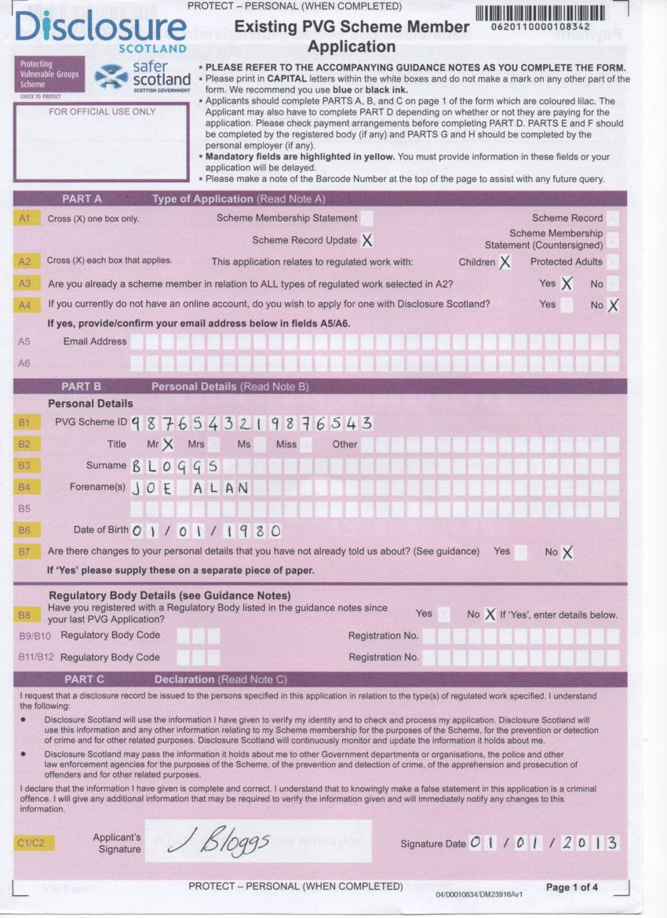
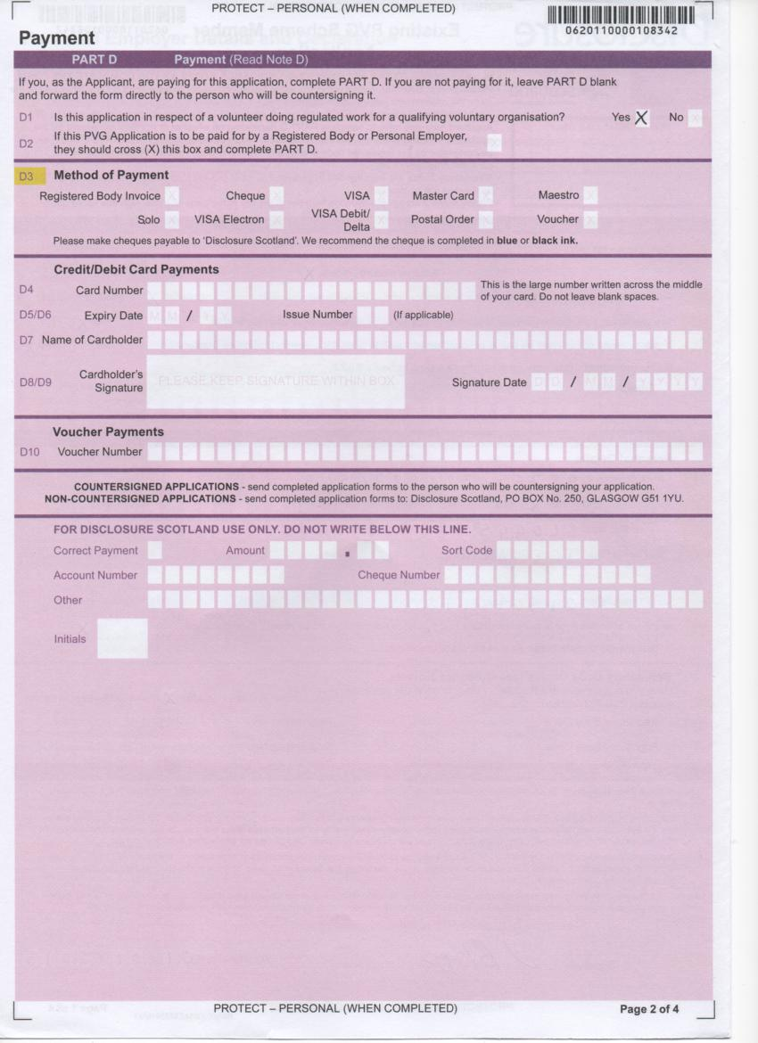
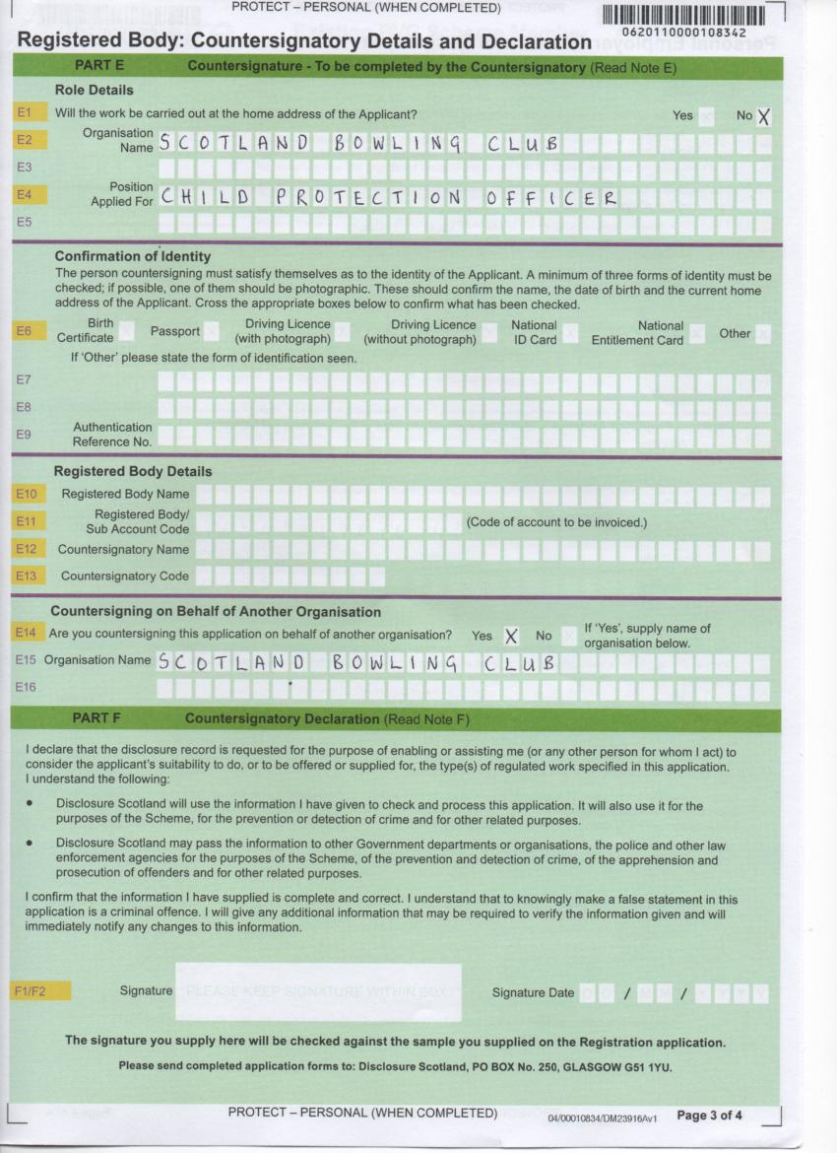

SECTION 5 – Verification

Who verifies the ID of the Child Protection Officer for their PVG application?

When the clubs Child Protection Officer completes a PVG application for their role in the club they obviously require someone to verify their identity. Rather than having to wait for a Bowls Scotland verifier to visit the club this task can be completed by a member of the club’s Board or Management Committee.

The Child Protection Officer should complete the PVG application form using the guidance notes on pages 28-29 (Application to Join the PVG Scheme) or pages 36-37 (Existing PVG Scheme Member). The Board or Management Committee member completing the identification checks should then complete the Child Protection Officer ID verification form on page 42. This form should be returned to Bowls Scotland along with the completed PVG application form.

Verifying other applicant’s identification

All PVG Scheme applicants require their identification to be checked before their application form is sent to Bowls Scotland. These identification checks must be completed by the club’s Child Protection Officer (CPO). The CPO can use the Identity Verification Guidance Notes issued by VSDS (page 45) to ensure the identification checks have been completed satisfactorily.

When conducting the identification checks the CPO must complete the Bowls Scotland PVG application coversheet on page 47. They should ensure that they have checked three pieces of identification, one of which must be photographic and one which must contain the applicant’s current address. Once completed the PVG application coversheet should be returned to Bowls Scotland along with the completed PVG application form and Self Declaration form (page 50-51) to:

Bowls Scotland
National Centre for Bowling
Hunters Avenue
Ayr
KA8 9AL

Child Protection Officer ID verification
(please complete this form on BLOCK capitals)

Club name:

Child Protection Officer’s name:

The following section should be completed by the verifier who must be a member of the club’s Board or Management Committee.

Verifiers name:

Address:

Postcode:

Contact number:

Contact E-mail:

Position in club:

I [enter verifiers name] can confirm that I have met with and positively identified [enter CPO’s name ]. I have checked in the manner recommended by Disclosure Scotland, the authenticity of the documentation supplied and the information recorded on the PVG Scheme Record Application Form.

Verifier Signature: Date:

Identification checked:
(please cross the appropriate boxes)

Three forms of identification should be checked. At least one must be photographic and one should contain the applicant’s current address.

Photo ID: at least one box must be ticked

Passport *Driving Licence with photo National Entitlement Card
(e.g FREE bus travel card)

*If the candidate has a middle name and has used a driving licence as proof of ID, please make sure the middle name has been recorded on the PVG application form.

Current Address ID: at least one box must be ticked

Phone Bill Utility Bill Bank Statement

Other (please state)

Other ID

Driving Licence without photo Birth Certificate

Volunteer Scotland Identity Verification Guidance Notes

This guidance is prepared to assist collators, lead and additional signatories to correctly verify the identity of applicants. Where VSDS cannot be satisfied that sufficient checks have been undertaken or that the applicant’s identification cannot be satisfactorily confirmed, we can refuse to counter sign the application form.
Under the agreement between VSDS and enrolled organisations, it is the responsibility of collators and signatories to take all reasonable steps to ensure that the applicant is who they claim to be.
A Signatory is therefore responsible for ensuring sufficient ID documents have been seen and are entitled to request as many forms of identification as they feel necessary to satisfy themselves that there has been no theft or manipulation of the applicant’s identity.
Similarly, acceptance of a person’s identification by a signatory does not place any obligation on VSDS to accept this statement as being true and, if deemed necessary, VSDS can require further checks to be undertaken by the signatory or refrain from counter signing the application.
Original documents will always carry greater weight than copies because copies can more easily be manipulated. At a minimum it is essential that you provide at least one item of photographic evidence (for physical identification purposes) and two separate items of address related evidence (to verify the applicant’s present address), unless it is a new style photographic drivers licence – see para “Photographic Drivers Licence” below.
The following lists are provided for your guidance. Lead and additional signatories should initially seek evidence of identity from amongst the items suggested. There may be other appropriate forms of identification that you can also rely on. If you are in doubt please contact us.

Range of Possible Photographic Verification that may be used
- Passport (e.g. UK or other country);
- Driving licence with photograph;
- Other forms of photo ID - CURRENT; UK Government Department Pass/Card, Employee ID Card, NHS Scotland ID Card, Armed Forces ID Card, National Union Student ID, University ID, Young Scot Card

Range of Possible Address Verification documentation that may be used

Please note that the address information should detail the current address.
- Bank or building society statement (within last 3 months)
- A utility bill (within last 3 months)
- Credit or store card statement (within last 3months)
- Financial statement (e.g. Mortgage, Personal loan papers, ISA)(within last 3 months)
- Correspondence from statutory bodies (e.g. Benefits Agency, Employment Services; central or local/government departments) (within last 3 months)
- Pension or other benefits book
- Visa
- Work Permit
- Driving licence without photograph

Suggested Alternative Range of Forms of Identification that can be used to Support Photographic and Address Verification:
- Current National Savings Card | - Current Credit/Debit Card
- Current Building Society Account Book/Card | - Current AA/RAC Card
- Current Trade Union Membership Card | - Current Form BF7 (Benefits Agency)
- Current Council Rent Book | - European Health Insurance Card (E11)
- Current Bank Giro
- Cheque Guarantee Card Combined with Current Personal Cheque Book
- Scottish Qualifications Authority ‐ Registration No. (School students)
- Degree Certificate; HND; HNC; Professional Qualification; NVQ/SVQ (granted by a UK University,
award granting body or equivalent)

Where you cannot provide Photographic Evidence of Identity (Passport etc)
If the applicant does not have the required documentation for photographic evidence (physical ID) then they should supply a passport sized photograph and a letter signed and dated by a responsible person (school guidance teacher; minister of religion; line manager etc) which states “I certify that [name of person] residing at [enter full address] has been known by me for [enter duration of time]. Sign, insert address and date.” Please note this letter should not be completed by the same person countersigning the VSDS multiple cover sheet.

Photographic Drivers Licence
The new style photographic drivers licence which contains address information would satisfy as evidence both of photographic evidence (physical ID) and present address verification.

[blank page]

Bowls Scotland
PVG application coversheet

Verifier / CPO name:

Name | Club | Scheme Record | Scheme Record Update | Paid Position | Voluntary Position | Application Ref No | Birth Certificate | Passport | Driving Licence | Driving Licence (No Photo) | Other | Regulated work with Children | Regulated work with protected adults

I understand and agree to comply with the requirements of enrolment with VSDS; the Ministerial Code of Practice and obtaining PVG Scheme Record disclosure checks. I confirm that these applications are in respect of persons who wish to undertake regulated work as defined in the Protection of Vulnerable Groups (Scotland) Act 2007.

I declare that to the best of my knowledge and belief, all the information that I have given in connection with these applications is full and correct in every respect. I undertake to supply any additional information that may be required by Bowls Scotland to verify the particulars given and also to inform Bowls Scotland of any alterations in these particulars.
Verifiers Signature: |  | Signature Date:

Please note we are unable to accept photocopied signatures
[blank page]

SECTION 6 – PVG applicants – additional information required

When each applicant completes either the ‘Application to Join the PVG Scheme’ or ‘Existing Member PVG Scheme Application’ form they should also complete the following document.

- Self Declaration Form (pages 50-51)
The Self Declaration Form asks the applicant to disclose all convictions (spent and unspent), cautions, and any relevant non-conviction information. This form will be stored by Bowls Scotland and only accessible to the Lead Officer and signatories for child protection. The form will only be stored until the club has made a recruitment decision on the applicant. If the applicant’s PVG certificate, issued by Disclosure Scotland, lists conviction or non-conviction information that may be relevant to the role they are going to fulfil then Bowls Scotland will review the applicant’s Self Declaration to see if this information was disclosed.

This form should be returned to Bowls Scotland along with the applicants ‘Application to Join the PVG Scheme’ or ‘Existing PVG Scheme Member Application’ forms.

If the applicant is new to the regulated work role with children in your club then they should also complete the following two documents.

- Code of Conduct for working with children (pages 52-53)
The club should put in place a Code of Conduct for working with children and ask all volunteers working with children in the club to sign a copy. The Code of Conduct makes clear to all volunteers what is expected of them in their role and what is unacceptable practice.

The Code of Conduct should also be signed by the Child Protection Officer who should then store the completed form with other child protection information in a secure file only accessible to them.

- Voluntary Role – Application Form (pages 54-56)
Although the club will usually know the volunteer taking on the role they should still put in place and follow recruitment procedures. The club should ask all volunteers taking on a regulated work with children role to complete an Application Form for the role. The club should then request a reference from the applicant’s two referees. A template ‘Letter to Referee’ can be found on page 57. If the applicant is still in employment one of the references should come from their employer where possible.

The completed Voluntary Role – Application Form and two references should be stored in a secure file by the club’s Child Protection Officer.

Self Declaration Form – Regulated work with children

The Protection of Vulnerable Groups (Scotland) Act 2007 (PVG Act)

Private & Confidential

The post that you have applied for is for regulated work with children. You are therefore required to disclose all convictions (spent and unspent), cautions, and any relevant non-conviction information.

Please give details regarding any convictions and cautions under the heading in Section 1.

Please give details of any relevant non-conviction information in Section 2.

If you have no convictions, cautions, or relevant non-conviction information please go to Section 3 and sign the declaration form.

CLUB NAME:

Section 1

- Please give the date and details of the conviction(s) that you were charged with, the sentence that you received and the court where your conviction(s) was heard.

- Please give details of the reasons and circumstances that lead to your offence(s)

- Please give details of how you completed the sentence imposed, (for example did you pay your fine as required, what conditions were attached to your probation/community service/supervised attendance order, did you comply with the requirements of your order/custodial sentence etc.

- Has any other organisation(s) supported you to work through any of the above issues

- What have you learned from the experience?

Section 2: Non-conviction relevant information:

Section 3

Declaration (I certify that all information contained in this form is true and correct to the best of my knowledge and realise that false information or omissions may lead to dismissal).

Print Name:

Signature:_________________________ Date: ____________________

NOTE: The information given in this form will be treated in the strictest confidence. Please seal this form in an envelope and return it to Bowls Scotland along with your PVG application form.

[Club Name] Bowling Club
Code of Conduct for working with children

[CLUB NAME] supports and requires all members to observe the following standards of practice, including verbal and non-verbal actions when involved in activities with children.

All concerns about breach of this Code of Conduct will be taken seriously and responded to in line with [CLUB NAME] Complaints Policy, Disciplinary Procedure and Procedure for Responding to Concerns about Child Abuse (DELETE/ ADD AS APPROPRIATE).

GOOD PRACTICE

- Make sport fun, enjoyable and promote fair play.
- Treat all children equally, with respect, dignity and fairness.
- Involve parents/carers wherever possible.
- Build balanced relationships based on mutual trust.
- Include children in the decision-making process wherever possible.
- Always work in an open environment, wherever possible. Avoid private or unobserved situations.
- Put the welfare of each child first before winning or achieving performance goals.
- Be an excellent role model including not smoking or drinking alcohol in the company of children.
- Give enthusiastic and constructive feedback rather than negative criticism.
- Recognise the developmental needs and capacity of children.
- Avoid excessive training and competition, pushing children against their will and putting undue pressure on them.

PRACTICE TO BE AVOIDED

In the context of your role within [CLUB NAME], the following should be avoided:

- Having ‘favourites’ – this could lead to resentment and jealousy by other children and could be misinterpreted by others.
- Spending excessive amounts of time alone with children away from others.
- Entering children’s bedrooms on trips away from home, unless in an emergency situation or in the interest of health and safety. If it is necessary to enter rooms, knock and say that you are coming in. The door should remain open, if appropriate.
- Where possible, doing things of a personal nature for children that they can do for themselves.

UNACCEPTABLE PRACTICE

In the context of your role within [CLUB NAME], the following practices are unacceptable:

- Engaging in sexually provocative games, including horseplay.
- Engaging in rough or physical contact unless it is permitted within the rules of the game or competition.
- Forming intimate emotional, physical or sexual relationships with children.
- Allowing or engaging in touching a child in a sexually suggestive manner.
- Allowing children to swear or use sexualised language unchallenged.
- Making sexually suggestive comments to a child, even in fun.
- Reducing a child to tears as a form of control.
- Allowing allegations made by a child to go unchallenged, unrecorded or not acted upon.
- Inviting or allowing children to stay with you at your home.
- A Coach and/or other leader sharing a room alone with a child.

Sign-up:

I have read and agree to abide by this Code of Conduct

I have also read and agree to abide by [CLUB NAME] Child Protection Policy, Procedures and Guidelines.

Name of staff member/volunteer:

Signature:

Date signed:

Witnessed by:
(Child Protection Officer, if possible)

Signature:

Date signed:

VOLUNTARY ROLE - APPLICATION FORM
Staff/Volunteer role applied for:

1. Personal Details:
Forename(s) Surname
Any previous name by which you’ve been known
Address  Postcode | Home Tel No
Work No
(please state if you don’t wish to be contacted at work)
 | Mobile No
 | Email Address

2. Current Employment:
Employer’s Name and address | Position: Date appointed:  Salary: Additional benefits:  Notice required and reason for leaving:  Please outline your duties and responsibilities:

3. Previous Employment (start with most recent)

From - To | Employer’s Name and address | Post held | Reason for leaving

4. Education and qualifications
From-To | Secondary Schools, Colleges, Polytechnics, Universities and other Institutions (indicate full or part-time) | Qualifications

5. Other training and qualifications
From-To | Please give details of any training courses (e.g., coaching courses etc) or qualifications relevant to this application | Qualifications

6. Supporting Statement
Please state how you think your skills and experience match the requirements of the job description and give your reasons for applying. Please include any relevant voluntary work (with dates) and technical skills which we should know about.

7. Additional Information
Please tell us if you feel we will need to provide any additional support to enable you to fulfil this role e.g. in relation to health, mental health or disability.

8. Interview Availability
Please advise of any dates you would be unable to attend an interview.

9. The Vacancy
How did you learn of this vacancy?

10. References
Please give details of two referees (preferably with first-hand knowledge of your previous work with children). References from relatives will not be accepted. Let us know if you do not want us to contact a referee prior to interview.
Name |  |  | Name
Address | Postcode |  | Address | Postcode
Tel No |  |  | Tel No
How do they know you? |  |  | How do they know you?
How long have they known you? |  |  | How long have they known you?

11. Declaration

Data Protection Act In order to recruit to the post [organisation name] will (within the terms of the Data Protection Act 1998) process personal information given in connection with this application. Information relating to the successful applicant will form part of personnel records. No other use will be made of information about applicants.
Consent I consent to the processing of personal information in the way described. As this role is regulated work with children, I consent to [Organisation name] requesting a Scheme Record/Scheme Record Update (as appropriate) under the Protection of Vulnerable Groups (Scotland) Act 2007.
Declaration I declare that to the best of my knowledge the information given on the form is true and correct. I understand that misleading statements or deliberate omission may be sufficient grounds for cancelling any appointment arising from my application.
Signed Date

To be completed by Child Protection Officer or Verifier.
I confirm that I have seen the following identification documents relating to [insert name of applicant]:
1.
2.
Note: At least one form of identification must be photographic.

Signed Date

Print name Position
LETTER TO REFEREES FOR REGULATED WORK WITH CHILDREN - TEMPLATE

Dear [insert name],

[name of applicant] has applied to volunteer with [Club name] in a role as [insert role] and has given your name as a referee. The position is regulated work with children. As an organisation committed to the welfare and protection of children we would like to know if there is any reason at all to be concerned about this applicant being in contact with children?

YES/NO Delete as appropriate. If you have answered yes we will contact you in confidence.

We would appreciate your honesty in providing us with some information which will allow us to consider their application. All the information on this form will be treated confidentially and in accordance with relevant legislation and guidance. Information will only be shared with the person conducting the assessment of the applicant’s suitability for the position.

How do you know the applicant and how long have you known them?

What qualities does this person have that would make them suitable to work with children?

Please rate this person on the following (please tick one):
 | Unsatisfactory | Satisfactory | Good | Excellent
Attendance
Responsibility
Maturity
Self motivation
Can motivate others
Ability to work as a team
Willingness to follow instructions
Commitment
Communication skills
Trustworthiness
Reliability

- If you have ticked unsatisfactory for any of the above, please provide more details.
- Please also use this space to provide any other information about the applicant which you consider is relevant to the position applied for (continue on a separate sheet if necessary).

I declare that all the information contained in this form is accurate and truthful to the best of my knowledge.

Signature: Date:

Print Name:

Please return this in an envelope marked PRIVATE and CONFIDENTIAL to:
[insert name of Child Protection Officer]

[insert address of organisation]

SECTION 7 – Other Relevant Information

10 Steps to Safeguard Children in Sport

The Bowls Scotland Child Protection Resource Pack has helped you to put in place the minimum requirements you must meet in order to process PVG application forms via Bowls Scotland, however, we would now encourage your club to review the ’10 Steps to Safeguard Children in Sport’ document produced by Safeguarding in Sport. The ’10 Steps to Safeguard Children in Sport’ are outlined on page 59 and the full document can be downloaded from the Bowls Scotland (www.bowlsscotland.com) or
Safeguarding in Sport (http://www.children1st.org.uk/services/87/safeguarding-in-sport) website.

Parental Consent

On pages 61-62 we have provided a ‘Partnership with parent / guardian’ template that can be used by your club to maintain a register of children playing bowls in the club and to obtain parental consent for their activities.

Significant Incident Form

More information on recording incidents and responding to concerns can be obtained from the ’10 Steps to Safeguard Children in Sport’ document, however, we have provided a template ‘Significant Incident Form’ on pages 63-64 that can be used if necessary.

Emergency Contact Numbers

We would strongly advise clubs to display in their clubhouse the contact details for their Child Protection Officer, local Police station and local authority social work department. Emergency Contact numbers for Police and social work can be found at the following link on the Safeguarding in Sport website.

http://www.children1st.org.uk/services/131/emergency-numbers

Regulated work with Protected Adults

If you believe any of your volunteers are going to be fulfilling a role that includes regulated work with protected adults then please contact Bowls Scotland for further advice. Please note that the volunteer is only likely to require PVG registration for working with protected adults if they are specifically teaching, instructing, training or supervising a protected adult or group of protected adults.

WHAT SHOULD YOUR ORGANISATION DO TO SAFEGUARD CHILDREN IN SPORT?

10 STEPS TO SAFEGUARD CHILDREN IN SPORT:

- Appoint a named contact to co-ordinate child protection within your organisation who has attended ‘Safeguard & Protecting Children’ or other basic child protection awareness training and ‘In Safe Hands – Club Child Protection Officer’ workshop.

- Adopt a Child Protection Policy at management/committee/board level within your organisation.

- Identify any risks to children participating in your activities.

- Get all adults working with children in your organisation to sign up to the Code of Conduct for working with children.

- Support all adults working with children in your organisation to attend ‘Safeguarding & Protecting Children’ or other basic child protection awareness workshops.

- Adopt and use an effective ‘recruitment and selection’ procedure to make sure new staff/volunteers have been carefully considered and vetted to do regulated work with children.

- Adopt ‘responding to concerns’ procedures to ensure that staff/volunteers get the appropriate help for a child or challenge the inappropriate conduct of any adults within your organisation.

- Adopt a ‘disciplinary’ procedure to ensure you can deal with any inappropriate conduct or child abuse and if necessary refer any individual to Disclosure Scotland for consideration on the Children’s List.

- Adopt a procedure to review any child protection concerns which have arisen to ensure procedures are followed and appropriate action taken in the best interests of the child.

- Adopt ‘Safe in Care’ guidelines that are appropriate to your organisation’s activities, e.g. trips away from home, physical contact, adult to child ratios, ICT and social media.

Remember to communicate all of the above to the children in your organisation and to their parents/carers so that everyone recognises and understands the important safeguards put in place to help keep children safe.

(Safeguarding In Sport, 2011)

The full ’10 Steps to Safeguard Children in Sport’ document can be downloaded from the Safeguarding in Sport or Bowls Scotland website.

[blank page]
[Club Name] Bowling Club
Partnership with parent / guardian

[Club Name] values the involvement of children in our sport. We are committed to ensuring that all children have fun and stay safe whilst participating in bowls. To help us fulfil our joint responsibilities for keeping children safe [Club Name] have Safe in Care Guidelines. These Guidelines tell you what you can expect from us when your child participates in bowls and details the information we need from you to help us keep your child safe.
We need you to complete this form at the start of every season and to let us know as soon as possible if any of the information changes. All information will be treated with sensitivity, respect and will only be shared with those who need to know.
Child’s Name: | Date of Birth:
Address:  Postcode: | Tel No:
Emergency Contact Name:  Relationship to Child: | Emergency Contact Tel No:
Late Collection Contact:  Relationship to Child: | Contact Tel No:
Name of GP: | Tel No of GP:
Address of GP:

Postcode:

- GENERAL & MEDICAL INFORMATION

Please complete the following details. If none, please state “none”.
- Does your child have a disability/medical condition that will affect their ability to take part in sport? If yes, please give details:

- Does your child take any medication? If yes, please give details:

- Does your child have any existing injuries (include when injury sustained and treatment received)? If yes, please give details:

- Does your child have any allergies, including allergies to medication? If yes, please give details:

- Is there any other relevant information which you would like us to know about your child? (e.g. access rights, disabilities, etc)

- CONSENT – MEDICAL TREATMENT

I consent / I do not consent (delete as appropriate) to my child receiving medical treatment, including anaesthetic, which the medical professionals present consider necessary.

- CONSENT – TRANSPORTATION OF CHILDREN

I consent / I do not consent (delete as appropriate) to my child being transported by persons representing [Club Name] individual members or affiliated clubs for the purposes of taking part in bowls.
I understand [Club Name] will ask any person using a private vehicle to declare that they are properly licensed and insured and, in the case of a person who cannot so declare, will not permit that individual to transport children.

- CONSENT - PHOTOGRAPHS AND PUBLICATIONS (INCLUDING WEBSITE)

Your child may be photographed or filmed when participating in bowls.
I consent / I do not consent (delete as appropriate) for my child to be involved in photographing/filming and for information about my child to be used for the purposes stated in [Club Name] Safe in Care Guidelines.

- CONSENT – CONTACT INFORMATION

[Club Name] may contact your child from time to time via email, text or social networking site.
I consent / I do not consent (delete as appropriate) for my child to be contacted via email, text or social networking site for the purposes stated in [Club Name] Safe in Care Guidelines. I do / do not (delete as appropriate) wish to be copied in to these messages.

- CONSENT – SIGNATURE

1. I am aware of the Safe in Care Guidelines for bowls and agree to work in partnership with [Club Name] to promote my child’s safe participation in bowls.
2. I am aware of [Club Name] Code of Conduct and Child Protection Policy and Procedures.
3. I undertake to inform [Club Name] should any of the information contained in this form change.

Parent/Carer’s Signature: Date:
(Please state relationship to child if not parent)
Print Name:

SIGNIFICANT INCIDENT FORM - TEMPLATE

This form must be completed as soon as possible after receiving information that causes concern about the welfare or protection of a child. The form must be passed to [Organisation name/Child Protection Officer] as soon as possible after completion; do not delay by attempting to obtain information to complete all sections.

Complete Part A of this form if the concerns relate to the general welfare of a child.
Complete Parts A and B if the concerns relate to possible child abuse.

PART A where there are concerns about general welfare of a child
- Child’s Details

Name: | Date of Birth:
Address:  Postcode: | Tel No:
Preferred Language: | Is an interpreter required? YES / NO
Any Additional Needs?

- Details of Person Recording Concerns

Name: | Position/Role:
Address:  Postcode: | Tel No:

- Details of Incident giving rise to Concerns
(including date, time, location, nature of concern, who, what, where, when, why)

- Details of any witnesses
(including names, addresses and telephone contacts)

- Details of injuries
(including all injuries sustained, location of injury and action taken)

PART B where there are concerns about possible child abuse
- Details of person about whom there is a concern

Name: | Relationship to Child:
Address:  Postcode: | Tel No:

- Details of concerns
(including date, time, location, nature of concern, who, what, where, when, why
Continue on a separate sheet if necessary)

- Details of any action taken

- Details of agencies contacted
(including date, time, name of person contacted and advice received)

10. Have the child’s parents/carers been informed? YES/NO (delete as appropriate)
If yes, record details / If no please state why not:

11. Child’s views on situation (if expressed). Where possible, please use the child’s own words.

Signed: Date:

Print Name: Position:

Checklist – Submitting a PVG Scheme Application Form

- Establish if the applicant is doing regulated work (pages 24).

- Check if the volunteer is already a PVG Scheme Member and select appropriate check (page 26).

- Identify the voluntary role the applicant is fulfilling (pages 5-8).

- Complete the appropriate PVG Application Form using guidance documents supplied (pages 26-40).

- Child Protection Officer (CPO) to check PVG Application Form completed correctly (pages 26-40).

- CPO to verify applicant’s identification using guidance notes on page 45.
Board / Committee member to complete ID checks for CPO if required (page 41).

- CPO to complete PVG Application Coversheet with all applicants details (page 47).

- Applicant to complete a Self Declaration Form (page 50-51).

- CPO to submit the following documents to Bowls Scotland, National Centre for Bowling, Hunters Avenue, Ayr, KA8 9AL.
- PVG application forms (Application to Join and Existing Scheme Member)
- Self Declaration Form
- PVG Application Coversheet

- Applicant to complete Code of Conduct for working with children (page 52-53).

- Applicant to complete Voluntary Role – Application Form (page 54-56).

- CPO to send ‘Letter to Referees’ to both applicants’s highlighted references (page 57).

- CPO to store the following documents in a secure file within the club.
- Code of Conduct for working with children
- Voluntary Role – Application Form
- References received from nominated referees

- Information highlighted above to be stored for as long as the applicant continues to fulfil their regulated work with children role in your club.

[blank page]
Club Child Protection Flowchart

We recommend putting a Child Protection Policy in place in case you have children accessing your facility.
Does your club have children who are members or provide coaching / social bowls sessions to children?
NO

YES
Put in place a Child Protection Policy using the template provided on page 9.
Display the Child Protection Policy within the club and make members aware of the policy.
Does the club have a Child Protection Policy in place and on display in the club?
NO

YES
Does the club have a Child Protection Officer (CPO)?
Recruit a CPO and make members, parents and children aware of who the CPO is.
Create role description for CPO (page 6) and advertise role to members.
NO

YES
Ask the club CPO to complete the Secondary Organisation Contract (pages 10-17) and e-mail to Bowls Scotland for checking.
Has the club CPO completed a Secondary Organisation Contract and submitted it to Bowls Scotland?
CPO to sign, date and submit the finalised SOC to Bowls Scotland.
NO

YES

Bowls Scotland will submit SOC to VSDS. Club can now process PVG applications.
CPO to book on the relevant training courses highlighted on page 20.
Has the CPO completed the relevant training courses highlighted on page 20?
NO

YES
Board / Committee member to complete verification of CPO’s ID and submit all relevant documents to Bowls Scotland.
CPO to complete the Application to Join the PVG Scheme or Existing PVG Scheme Member form (page 26-40).
Has the CPO completed a PVG Scheme Application form?
NO

YES
Complete ‘Member Club Child Protection Contact Information’ form on page 22 and submit it to Bowls Scotland.

On receipt Bowls Scotland will send a Child Protection certificate to the club recognising the nominated person as the CPO.

