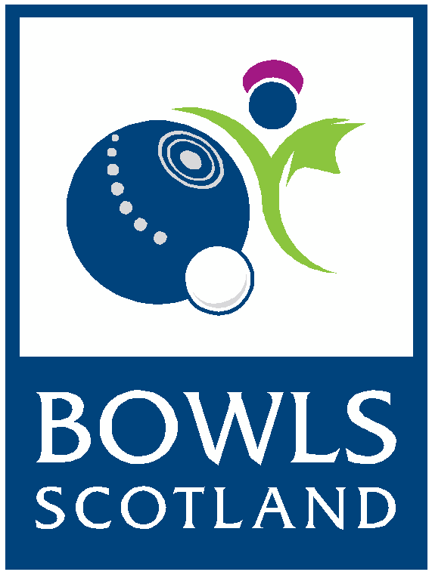
BIWBC Junior
International Series 2018
Application Form

Please read the following details before completing the application form:

- Applications are welcomed from anyone wishing to be considered for selection
- Applicants must be 25 or under on or before 1st April 2018 to be able to play in the BIWBC Junior Team
- Closing date for submitting an application is Monday 16th April, no late applications will be considered
- Your application will be acknowledged by email upon receipt
- You will be advised whether your application has been successful by Friday 27th
April 2018
- Successful Applicants must attend the BIWBC Junior Squad Days which will take place on Saturday 2nd & Sunday 3rd June at Northfield, National Centre For Bowling, Ayr
- Please note; travel expenses to Squad Days will not be covered by Bowls Scotland
- The BIWBC Junior International Series will take place at Victoria Park, Leamington Spa on the 21st & 22nd July 2018 (departing Scotland on 20th July and returning on the 22nd July). Accommodation and travel will be provided.

- Application Forms must be returned either by email or post to the following:
Bowls Scotland
National Centre for Bowling
Northfield
Hunters Avenue
Ayr
KA8 9AL

Email: BIWBC@bowlsscotland.com
Telephone Enquiries: 01292 294623

Further information on the selection process can be found on the Bowls Scotland website: www.bowlsscotland.com

APPLICATION FORM
BIWBC Junior International Series 2018
Please complete the application form in BLOCK capitals

PERSONAL INFORMATION
Name:

Address:

Post Code:

Telephone Number:

Date of Birth:

Email address:

Name of club:

Shirt Size: XS S M L XL XXL XXXL Other…………..

What would be your top two preferred positions in the team if you were selected to play for Scotland in the BIWBC International Series? Please indicate your first and second choice only:
1st Choice:
Lead Second Third Skip
2nd Choice:
Lead Second Third Skip

PERSONAL ACHIEVEMENTS
Please complete the details of your achievements, showing all honours, at the following levels over the past 3 years:

British Isles Level
2017

2016

2015

Scottish Super Series
2017

2016

2015

National Level (second stage)
2017

2016

2015

County Level (Including Torrance Purvis/Inter Association County Games)
2017

2016

2015

Club Level or SYBA
2017

2016

2015

Internationals
(PLEASE TICK THE BOXES FOR ANY YEARS YOU HAVE PLAYED AT INTERNATIONAL LEVEL)
2017 | 2016 | 2015 | 2014 | 2013 | 2012 | 2011 | 2010 | 2009 | 2008

How often do you play competitive bowls? (i.e. Representing your club at County/Inter Association or Scottish ties)

Please list any other achievements in support of your application (continue on separate sheet if necessary):

Data Protection
The information provided on this application form will be stored and accessed only by Bowls Scotland. This information will be used for the purpose of selecting players for the BIWBC Internationals in 2018.
I HAVE READ AND UNDERSTOOD THE ABOVE INFORMATION AND GIVE CONSENT FOR MY PERSONAL INFORMATION TO BE USED BY BOWLS SCOTLAND. ALL INFORMATION PROVIDED IN THIS FORM IS TRUE TO THE BEST OF MY KNOWLEDGE.
Signature:
Date:

