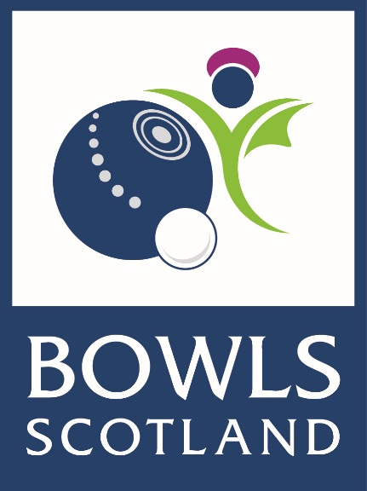

Child Protection
Emergency Contact List

Bowls Scotland Child Protection Lead Officer, Lawra Cox
Tel: 01292 294623 Mob: 0771 502 5736

Police – Emergency
Tel: 999

Police – Non Emergency
Tel: 101

Social Work
Tel: 101 and ask to be connected to the local social work

