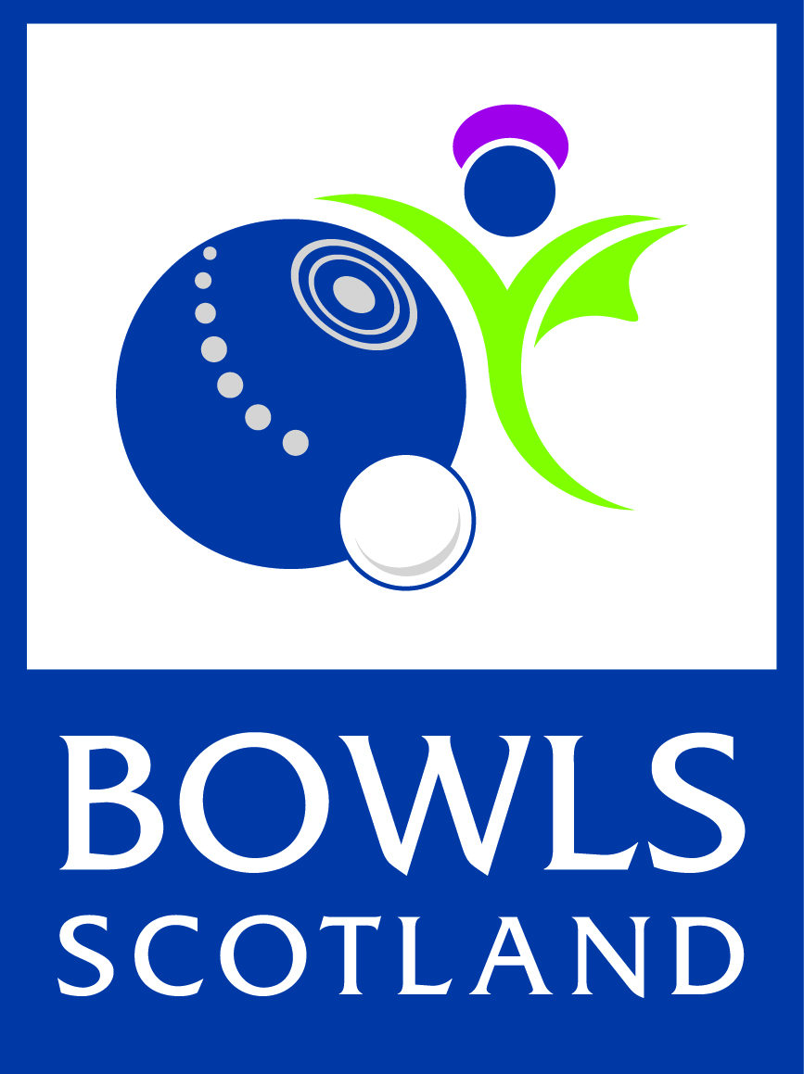

Bowls Scotland Strategic Director of Competitions and Events

Bowls Scotland is looking to expand the current board through the co-option of a Strategic Director for Competition and Events.

We are looking for applications from interested people who fit the Role Description below.

The successful individual will work with the Board to develop the strategic direction of Competition and Events in Scotland at Local, National and International level.

This is not an operational, hands-on role as this is already being successfully delivered by the current Director of Competitions and the Competitions and Events group.

The individual should have the following experience/skills.
• A working knowledge of bowls
• Proven experience of having a strategic focus
• Experience and a good understanding of delivering events
• An understanding of how the sport fits at a local, national and international level

The Strategic Director of C&E would be expected to fulfil the following requirements.
• Lead on the strategic direction for Bowls Scotland competitions and events at domestic, national and international levels.
• Work with the Board to develop the short, medium and long term strategic direction against the 2015-2019 framework and beyond.
• Inform and guide strategy relevant to the delivery of modern, sustainable and viable competitions and events
• Work closely with the Director of C&E- Operational- to enable us to deliver the current and future strategies.

If you would like to apply for this exciting position to help shape the future of the sport in this country, please send in a one-page summary of your experience to date plus a statement giving some ideas on your thoughts for the strategic future of Competition and Events over the next 10 years. This should be received at the Bowls Scotland office, marked for the attention of the CEO by August 18th 2017.
A panel from the Board will like to have a ‘face to face’ discussion with applicants they feel can deliver. These discussions will take place on the 24th of August.

Alan McMillan
CEO
Bowls Scotland
National Centre for Bowling
Northfield, Hunters Avenue,
Ayr KA8 9AL

Email: info@bowlsscotland.com

