SPECTATOR & PARENT CODE OF CONDUCT

I will:
- Remember that children play for FUN
- Stay outside the field of play and in the Spectator’s Area (where provided)
- Never engage in, or tolerate, offensive, insulting or abusive language or behaviour
- Always respect the match officials' decisions
- Applaud effort and good play as well as success
- Let the coaches do their job and not confuse the players by telling them what to do
- Encourage the players to respect the opposition and match officials
- Never criticise a player for making a mistake; mistakes are an important part of learning
- Pass on any concerns that I have about the wellbeing or welfare of a child to a club official
I understand that breaches of the code may result in action being taken by my club or governing body.
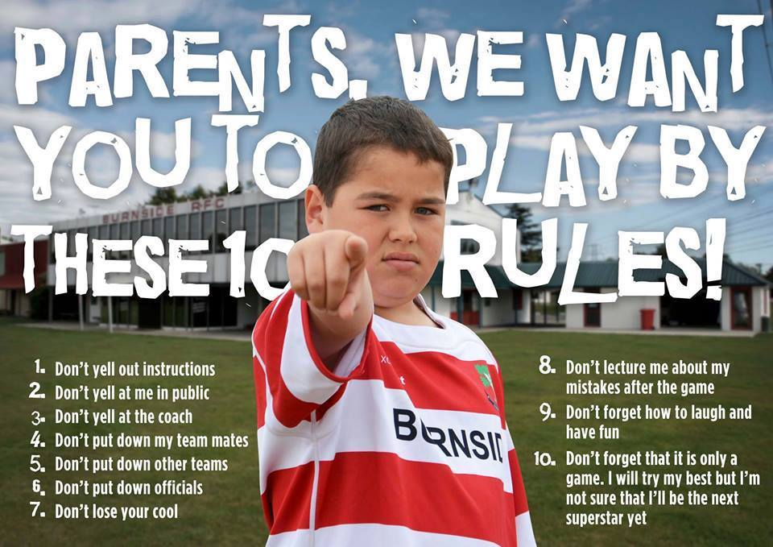

If you have any concerns about the welfare of a child, you can contact Safeguarding in Sport on 0141 419 1156.

Spectator & Parent code of conduct courtesy of Children 1st

