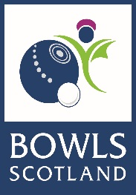

Selection Appeals Procedure

There are no appeals allowed against the content of the selection criteria and therefore against the actions of the selection panel, provided they follow the selection criteria.

Appeals will only be considered on the grounds of;

- The selection policy process was not followed
- Some other misconduct of the selectors
- New evidence that the panel may be unaware of as relates directly to the non-selected athlete

- An Athlete (the Appellant) may appeal to have the decision of Bowls Scotland selection panel reviewed by the Appeals Panel.

- The Appellant should lodge an appeal in writing within 48 hours after the selection decision has been communicated to them to CEO@Bowlsscotland.com or in writing to; CEO Bowls Scotland Northfield Hunters Ave Ayr KA8 9AL marked Private and Confidential.

- The notice of appeal should set out in full the basis of which the Appellant wishes to appeal and should be accompanied by all relevant and supporting documentation.

- The Appeal panel will meet within 5 days of the appeal being received, where the Appellant will be invited to attend. If the Appellant is unable to attend a decision will be made based on the previously submitted documentation. Bowls Scotland have 5 working days to communicate a response to the Appellant.

- The decision of the appeals panel is final and the appellant has no further right to appeal.

- Members of the Appeals panel will have had no previous involvement in the Selection Policy and 1 member will be from outwith Bowls Scotland.

