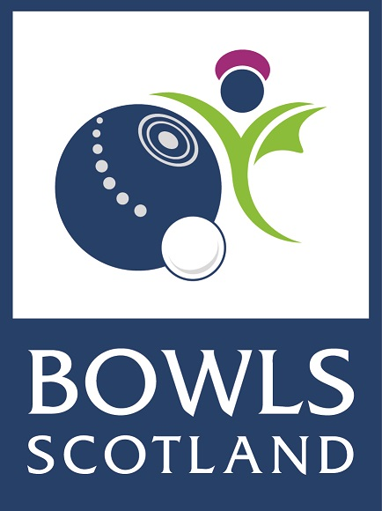Water Rates
Club Information sheet
November 2015

This document has been produced following discussions with Scottish Government and the Scottish Sports Association, and by drawing relevant information regarding the exemption scheme from online resources.

Introduction

In April 2015 the Scottish Government launched the Scottish Government Charities Exemption Scheme which helps Charities and Community Amateur Sports Clubs (CASCs) with the cost of their water and waste water bills. This scheme replaced the Water Charges Exemption Scheme which launched in 2002

From discussions with member clubs it is our understanding that many bowling clubs have been exempt from charges since the inception of the Water Charges Exemption Scheme in 2002. This has been highlighted to us by individual members and clubs who are concerned about the requirement to pay water and waste water bills from April 2016.

If your club is licensed under the Licensing (Scotland) Act 2005 or its predecessor then under the terms and conditions of the Water Rates Exemption Scheme you should not have been exempt from charges.

Scottish Government Charities Exemption Scheme

Under the new scheme support is available to charities registered with the Scottish Charity Regulator (OSCR) and CASCs with an income below £300,000. However, there are a few exceptions. Charities and CASCs will not be eligible for support where one or more of the following conditions are met:

- the charity holds a permanent alcohol licence to sell alcohol at the premises;
- the premises is a charity shop or other premises used for the purposes of retailing new or second hand merchandise;
- the premises operates as a café which is open to the public and operated on a regular basis to generate income. This excludes canteens that have been provided by the charity to support its own volunteers;
- the organisation is a Local Authority or an Arms-length External Organisation, organisations that can be used by Councils to deliver services.

Full details of the scheme including the terms and conditions can be found on the Scottish Government’s website at: http://www.gov.scot/Topics/Business-Industry/waterindustryscot/watercharges/exemptionscheme.

FAQs can be viewed at the following link: http://www.scottishwater.co.uk/business/our-services/charities-exemption-scheme/charities-exemption-scheme/frequently-asked-questions

The new scheme will be reviewed again in 2017-18.

What does it mean for my club?

If your club is not a registered Charity or CASC then you are not eligible for support for water and waste water charges.

If you have been exempt from these charges until now then Scottish Ministers have agreed transitional arrangements which provide exemption to all members of the current scheme in 2015-16 and a 50% reduction in wholesale charges for 2016-17. Thereafter, those clubs that are not eligible for the new scheme will be expected to pay for water and waste water services.

The clubs who this change will impact upon most significantly is those who are not a registered Charity or CASC and do not have a permanent alcohol license. Any member club in this position may wish to consider whether becoming a Charitable Organisation or CASC would be an appropriate legal structure for their club.

How do we join the scheme?

If you are already eligible under the current arrangements then you will be exempt from charges in 2015-16. In the coming months licensed providers will contact their customers that are eligible for the existing scheme to advise them what they need to do for 2016-17.

The application process for the new scheme is open to new entrants. If you believe you are eligible for the scheme and have not been receiving water rates relief then you should complete an application form as soon as possible. As long as the application is received by Scottish Water by 31 March 2016 and it meets the scheme requirements then successful organisations will receive support from 1 April 2015. Application forms should be sought from your licensed provider.

Further information about joining the scheme can be found in the FAQ document: http://www.scottishwater.co.uk/business/our-services/charities-exemption-scheme/charities-exemption-scheme/frequently-asked-questions

How do we start paying water and waste water charges?

As outlined above if your club has been exempt until now then you shouldn’t need to pay any charges until 1st April 2016.

If you do not currently have a licensed provider then you will need to select one. Information on all licensed providers can be found at the following link www.scotlandontap.gov.uk/suppliers.

The licensed provider will offer direction on how costs are calculated and in most cases will install a water meter as part of the service. If you do not have a meter then costs are calculated based on the rateable value of your property so we would advise clubs to ensure the licensed provider will install a meter.

How can we save on water and waste water charges?

All clubs are advised to consult their licensed provider for advice on reducing their water charges. Potential savings can be made from simple measures such as paying by direct debit or using a paperless service but can also be achieved through site visits from licensed providers and audits of your facility.

In some cases licensed providers may also be able to reduce costs for water that is used on your bowling green.

