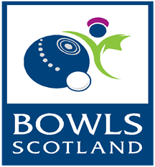
Regional Academy
2017
This is an exciting opportunity for under 25 players, who have the long term goal of
representing Scotland on the World Stage by being part of the Performance
Pathway. Players must be fully committed to be part of the Regional Academy
programme supported by Bowls Scotland.
Players will be able to develop their skills and improve their all round performance
through regular coached sessions, inter Regional competitons and squad sessions
in a High Performance environment. Selections will be based on previous results
and you may be selected to attend a Talent ID Day on 14th May 2017 when final
selections will be made.
There will be 5 Regional Academies across Scotland in the North, East, West,
South West and Central Tayside and Fife. Coaches will be allocated to each
Region to help with the delivery of the Academy in their local area to the players.
Up to 50 players will be selected across the country.
Players must be 25 or under on 1st April 2017.

If you are genuinely interested in being part of this great opportunity to develop
your skills and improve Performance please complete the application form and
return by 31st March 2017 to Info@bowlsscotland.com or by post to
the address below.

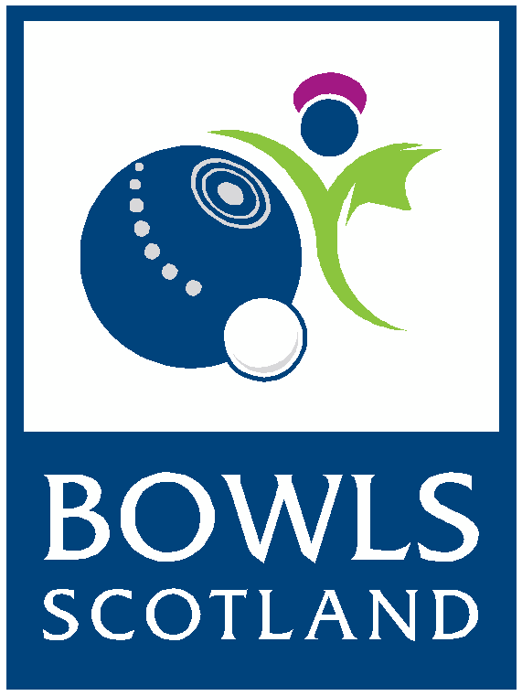

REGIONAL ACADEMY
APPLICATION FORM

Closing date for applications is 31st March 2017
Please complete in BLOCK capitals:
Name: ......................................................................................................................................
Address: ......................................................................................................................................
………………………………………………………………Postcode………………………………….
Telephone Number: ......................................................................................................................................
Email address: ......................................................................................................................................
Date of Birth:
……………………………………………
Name of club: ......................................................................................................................................
Please complete the details of all your bowling achievements over the last 3 years:
.......................................................................................................................................
.......................................................................................................................................
.......................................................................................................................................
…………………………………………………………………………………………………..
……………………………………………………………………………………………….....
…………………………………………………………………………………………………..
…………………………………………………………………………………………………..
…………………………………………………………………………………………………..

………………………………………………………………………………………………….
………………………………………………………………………………………………….
………………………………………………………………………………………………….
…………………………………………………………………………………………………..
…………………………………………………………………………………………………..
Please give a short statement on why you feel you would benefit from being selected into the Regional Academy:
……………………………………………………………………………………………………………
……………………………………………………………………………………………………………
……………………………………………………………………………………………………………
…………………………………………………………………………………………………………
Forms must be returned to Bowls Scotland by Email (Info@bowlsscotland.com) or by post to Bowls Scotland, National Centre for Bowling, Northfield, Hunters Avenue, Ayr KA8 9AL-clearly marked Regional Academy
Your application will be acknowledged upon receipt.
You will be advised whether you are being invited to the Talent ID Day on 14th May by 16th April
Data Protection
The information provided on this application form will be stored and accessed only by Bowls Scotland. This information will be used for the purpose of selecting players for the trials for the Regional Academy
I HAVE READ AND UNDERSTOOD THE ABOVE INFORMATION AND GIVE CONSENT FOR MY PERSONAL INFORMATION TO BE USED BY BOWLS SCOTLAND.
ALL INFORMATION PROVIDED IN THIS FORM IS TRUE TO THE BEST OF MY KNOWLEDGE.

Signature:
Date:

Parent /Guardian:

(if applicant under 16)

Chest Size (in inches)

