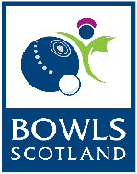
Bowls Scotland

National Championships 2017

Trade Stand Application Form

Please complete the form below (IN BLOCK CAPS) and return to the Bowls Scotland office by Friday 2nd June 2017. The information you give on this form will appear on your invoice:

EVENT DATE | Monday 24th July – Saturday 29th July 2017
COMPANY NAME:
CONTACT NAME:

ADDRESS:

CONTACT TEL:

EMAIL ADDRESS:
COMPANY WEBSITE:
FULL DESCRIPTION OF PRODUCTS SOLD / SERVICE PROVIDED:

SIZE OF RETAIL SPACE REQUIRED:
ADDITIONAL SET UP REQUIREMENTS:
PAYMENT METHOD:

